User Manual: Touch Screen

| july-20 |

**Document Overview**

**Documentation Goals**

This documentation is intended to provide instruction for ***The Touch Screen System****.*

**Documentation Disclaimers**

* Teach a user how to utilize the touch screen system for warehouse and machine floor computers that do not have keyboards.
* Provide instructions for adding and monitoring employees, shifts, and breaks.
* Provide instructions for adding and monitoring machines.

**Table of Contents**

**Overview of Advantzware Specific Keys and Icons** 6

Function Keys 6

Advanced Software Standard Function Keys 7

Program Icons 8

**Overview** 9

**Data Collection / Login [TD]** 10

Main Menu 10

Login / Logout 10

Employee Password Login 10

Employee Login Machine 12

Data Collection 14

Job Number Selection 15

Form Number 16

Pass Number 16

Machine Transaction Data 17

Machine Data Collection Auditing 18

Browse Transactions 18

View Transaction 19

Add/Update Transaction 20

Employee Status 22

Machine Status 23

Job Checklist 24

**Post Touch Data to ASI Database [TP]** 25

**Reports for Touch Screen [TR]** 27

Daily Summary by Employee [TR1] 27

Employees List [TR2] 29

Machine Transactions [TR3] 31

Completed Machine Jobs List [TR4] 33

Shifts List [TR5] 35

Machine Assigned Charge Codes [TR6] 37

Machine Assigned Shifts List [TR7] 39

Employee Types List [TR8] 41

Labor Report [TR9] 43

Employee Time by Job and Machine [TR)] 45

In/Out Transaction Report [TR!] 47

Employee Time Sheet [TR@] 48

Unreported Labor Report [TR#] 49

Time Calculation and Shifts 49

Machine Notes Report [TR$] 51

**File Maintenance for Touch Screen [TF]** 53

Employees [TF1] 53

Browse Employees 53

Employee Phone Information: View Phone Information 55

Add/Update Employee Phone Information 56

Add/Update Employee Phone Information Field Definitions 56

Email Notification System Options 58

Employee Notes – View 60

Add/Update Notes 61

Employee Address Information: View Address Information 63

Add/Update Address 64

View Employees 66

Add/Update Employees 67

Pay Rates 69

Add/Update Pay Rates 70

Log In/Out 72

Add/Update Machine Log In/Out 73

Machines 74

Add/Update Machine 75

View Notes 76

Employee Transaction Summary [TF2] 77

Browse Employee 77

Log In/Out 78

Detail 79

Add/Update Login/Out Transaction 80

View Notes 81

Machine Transactions [TF3] 82

Machine Data Collection Auditing 82

Browse Transactions 82

View Transaction 83

Add/Update Transaction 84

Employee Transactions by Machine 86

Add Employee 87

Posted Transactions 89

Employee Transactions [TF4] 90

Browse Employees 90

View Employee 91

Add/Update Employee Transaction 92

Machine 94

Log In/Out 95

Add/Update Log In/Out 96

Posted Transactions 97

All Notes 98

Completed Machine Jobs [TF5] 99

Browse Jobs 99

View Jobs 100

Job Sequence [TF6] 101

Browse Sequence 101

View Sequence 102

Add/Update Sequence 103

Shifts [TF7] 104

Browse Shifts 104

View Shift 105

Add/Update Shift 106

Breaks 108

Add/Update Break 109

Machine Assigned Charge Codes [TF8] 110

Browse Machine 110

View Machine 111

Add Machine 112

Machine Sequence 113

Add Machine Sequence 114

Machine Assigned Shifts [TF9] 115

Browse Machine 115

View Machine 116

Add Machine 117

Employee Default Rates [TF)] 118

Browse Rates 118

View Rate 119

Add/Update Rate 120

Employee Types [TF!] 122

Overview 122

Browse Types 122

View Type 123

Add/Update Type 124

Repost Touch Data to ASI Database [TF@] 125

Purge Employee Transaction [TF#] 126

Purge Touch Data [TF$] 127

Purge Zero Time Transaction [TF%] 129

**Copy or Replace Machine (STRIP)** 130

Touch Screen: Machine Code 131

Touch Screen: Job Data Collection 133

Touch Screen: Enter Job 133

Touch Screen: Operator Code 134

# **Overview of Advantzware Specific Keys and Icons**

## Function Keys

|  |  |
| --- | --- |
| BRWS | The browser, which is a list of records in this file. This is functionally equivalent to the Find option of our standard package. |
| VIEW | View record provides the ability to ADD, CHANGE, DELETE, and UPDATE an individual record. |
| SORT BY | The selections at the bottom of the browser, which will sort the list alphabetic order. |
|  |  |
| Update | Update the current record. |
| Reset | Reset the current record. |
| Add | Add a record. |
| Copy | This will copy the existing record. |
| Delete | Delete the current record displayed on the screen. |
| Cancel | Cancel the information that was entered. |
| Save | Save the record. |
|  |  |
|  | Takes the user to the first current record. |
|  | Moves backward one record. |
|  | Moves forward one record. |
|  | Takes the user to the last current record. |
|  |  |
| F1 | Miscellaneous Fields |
| F3 | Search |
| F3 | List |
| F4 | Notes |
| F6 | Browse |
| F7 | Viewer |
| F12 | Exit |

## Advanced Software Standard Function Keys

|  |  |
| --- | --- |
| Next | Shows the next sequential record. |
| Prev | Shows the previous record. |
| Add | Add a record. |
| Change | Change the current record displayed on the screen. |
| Delete | Delete the current record displayed on the screen. |
| Find | Find a record by searching by description. |
| “1”, “2” | Number 1 or 2 to go the first or second page of this record. |
| Esc | Escape from the current transaction without updating. |
| Q | Quit from the current transaction without updating. |
| F1 | Save |
| F3 | Help information is available on every data field. Simply place the cursor on a field and press F3 to display documentation regarding this particular field. |
| F3 | To insert additional data in a data field without erasing the information currently displayed. |
| F4 | Notes – General |
| F1 | Field Lookup is available on every data field which is maintained in a separate file. Place the cursor on a field and press ***“F1”*** to search for the code by description or to advance a screen of records by pressing the next key. Place the cursor next to the desired record and press enter to transfer the record to the data entry screen. See ***“Page Up”*** / ***“Page Down”*** keys below as an alternative |
| F7 | Delete |
| F8 | Notes – File Specific |
| Enter | Advances the cursor to the next field |
| Page Up | Will skim forward through each record in a data file in sequential order |
| Page Down | Will skim backward through each record in a data file in sequential order |
|  |  |

## Program Icons

|  |  |  |
| --- | --- | --- |
|  | Job Notes |  |
|  | Customer Attachments | Attach files (such as Word/Excel/Images) for this specific customer order. |
|  | Change Move/Set Column Mode |  |
|  | Print Acknowledgement |  |
|  | Export to Excel |  |
|  | Add |  |
|  | Attachments | Attachments for this Estimate. Will transfer to all future repeat orders for this estimate. |
|  | Notes |  |
|  | Spec Notes | Notes for specific finished goods items. |
|  | Utility Application |  |
|  | Help |  |
|  | UDF Viewer |  |
|  | Commissions |  |
|  | Exit |  |
|  |  |  |
|  |  |  |

# **Overview**

The touch screen data collection module is a Windows-based application that does not require a keyboard or mouse out on the plant floor, because it utilizes touch sensitive computer workstations which respond to the heat or touch of a fingertip. The program was designed to display a numeric keypad and an alphabetic keyboard on data entry screens so that the operator can enter production data, employee password characters or a numeric job number. The keyboard and numeric keypad, which are displayed on the screen, allow the user to press the letter or number for data input purposes, hence eliminating the need for a mouse or a keyboard.

One major difference between our touch sensitive data collection module and the Advantzware data collection module is that this new program features employee tracking of hours and cost in addition to the machine time. The touch screen transactions must be posted, which transfers the data to the Advantzware data collection module, which in turn must be posted to update the job costing system.

To speed the data entry process on the plant floor, several files must be defined with consistent default information. For example, each employee must be created in the employee file and each employee’s labor rates must be defined for each machine or for each shift. In addition, valid machines may be defined for each employee so that the machines will display on the workstation immediately during the data collection process.

Perhaps the greatest advantage to the touch screen technology is the speed and ease of use for entering job data information. This is achieved because each machine has an established job sequence of operations defined in the machine file.

When the operator selects a machine, the first sequence will appear immediately with the current time in hours and minutes as established on the file server computers system with A.M. and P.M. displayed just as any clock display. This saves the operator the time it takes to determine the start time and stop time of each operation as well as the time that it takes to enter the operation charge code.

The only data input requirement for the operator is to enter the actual quantity produced and the actual quantity wasted during set up and running the machine. The system automatically calculates the number of hours between each consecutive step in the manufacturing process, thereby saving the operator time and eliminating errors due to human calculations.

The process begins when the machine operator presses the machine button, then the job number button, which starts the set up. Next, confirm the accuracy of the current time displayed and press the ***“Start Make Ready”*** button.

Once the make ready has been completed, select the job number, which causes the next operation called stop make ready to display on the screen, however he should first record the actual waste produced during set up.

Next, the program will immediately prompt to start production running time. Press the button called ***“Start Running”.*** Once the production has been completed, the operator will select the job. The screen will display ***“End Run”***. However, the operator must push the button to add quantity produced by pressing the numeric keypad displayed on the screen. In addition, the operator should also record the waste produced during the production process.

Whenever the touch sensitive plant floor data collection screen is active, an audit trail displays at the bottom of the screen to make fast corrections to any errors made during the process.

# **Data Collection / Login [TD]**

## Main Menu

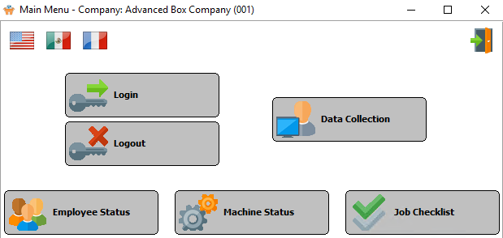

## Login / Logout

### Employee Password Login

To log into a machine the employee must select their name then enter their password. They may enter their password with the keyboard displayed on the computer screen.

Please Note: The computer keyboard displayed on the workstation may be changed in the file maintenance program. Several keyboard configurations are available including the normal computer keyboard known as qwerty keyboard plus an alphabetic keyboard showing the letters in alphabetical order.

The employee log in screen provides the ability for each employee to log into a machine each day. The employee must log in and log out of a machine once a day. If an employee works on multiple machines during the day, the employee will simply log into the other machine without needing to log out of the existing machine.

All of the daily job transactions that are recorded during the day will automatically extract the employee hours for each machine to calculate the total labor hours and the labor costs or each machine and job.

Companies that do not want to record employees individual times may assign a machine code as the employee and log in with the machine code rather than have each employee log in and out.

#### Choose Employee Name Screen

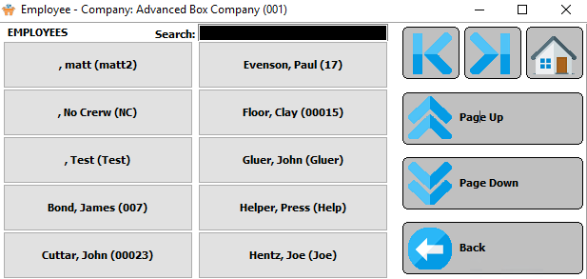

#### Password Screen

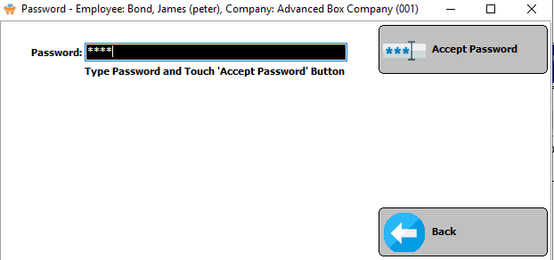

### Employee Login Machine

Once the employee logs in by entering the correct password, the employee must select a machine.

#### Select a Machine

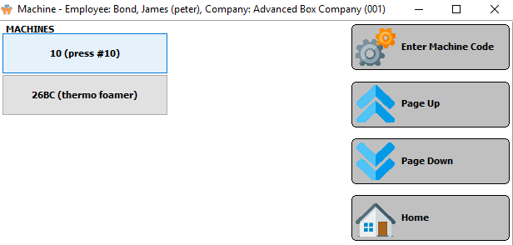

To select a machine, a list will display on the workstation as defined in the employee file.

All the machines that the employee will operate during the day are listed on the workstation for selection.

Please Note: The employee does not have to log out of the previous machine, the system will automatically log the employee out of the previous machine as soon as the employee logs into a new machine.

#### Enter Machine Code

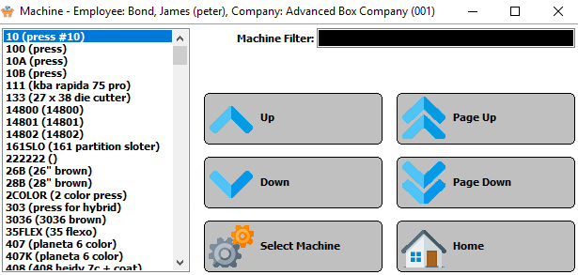

If the machine is not listed on the screen, then press the ***“Enter Machine Code”*** button to select another machine code. When an employee moves from one machine to another during the day, the employee must log into a machine.

#### Machine Transactions

Once an employee has logged onto a machine, all machine transactions recorded for each job will extract the employee’s labor costs and apply this labor cost to each job. Therefore, if three or four employees log into the printing press in the morning and log out at the end of the shift, they do not need to record any transactions for each job.

The main operator of the printing press will record the setup, production, downtime and cleanup times for each job.

The program will apply the cost of each employee to each job produced based on the length of time of each machine transaction for each job.

## Data Collection

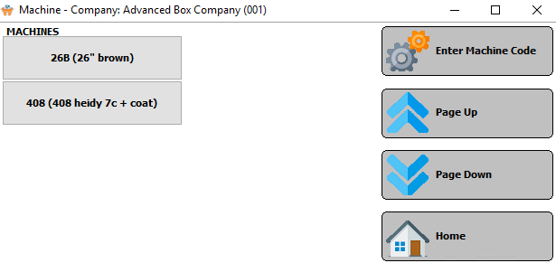

The job data collection provides the equivalent functionality of the Advantzware data collection program; however, it does not require the operator to calculate the start time, stop time or operation code. The time displays and is automatically calculated on the operator's screen for each operation step calculating the hours and minutes for each process.

To start adding machine data, just press the ***“Job Data Collection”*** button followed by the machine where the operator will begin his work. A list of machine buttons will appear representing the machines, which the employees have selected via the log in process. The operator may press the ***“Page Up” / “Page Down”*** buttons to show additional machines.

The operator records each machine operation step including the beginning of make ready, ending of make ready, beginning production, ending of production running, start and stop times for cleanup and any downtime.

Please Note: The Advantzware data collection requires both steps to be completed before entering the transaction, whereas the touch screen technology allows the operator to record both the start and stop process separately.

#### Enter Machine Code



If the machine is not listed on the screen, then press the ***“Enter Machine Code”*** button to select another machine code. When an employee moves from one machine to another during the day, the employee must log into a machine.

### Job Number Selection

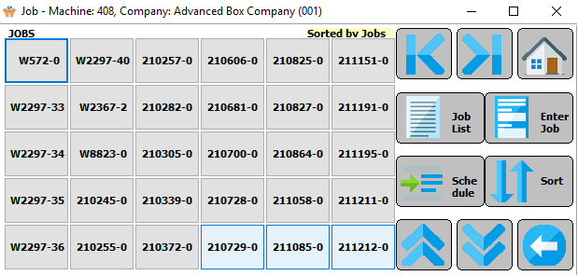

#### Job List

Once the operator has selected a machine, a list of open “***Job Number***” buttons for this machine center will display on the screen. Once the operator has selected the job number, the program will proceed directly to the data collection screen.

The jobs can be sorted by either *Job Number* or *Start*. This is achieved by pressing the ***“Sort”*** button.

If the desired job is not shown on the screen, the operator may press the ***“Page Up”*** / ***“Page Down”*** buttons to select more jobs. As an alternative, the operator may press the “***JOB LIST”*** button, which will show a numeric list of all jobs for selection by the operator.

#### Enter Job

The operator may press the “***Enter Job***” button and enter the job number with the numeric keypad buttons displayed on the workstation.

Once the operator has selected the job number, the program will proceed directly to the data collection screen.

### Form Number

For a folding carton combination job or for a corrugated set job, the system will prompt with a “***Form Number***” button, which represents the sheet size for each form which is being currently being converted. It is critical that the operator select the correct ***“Form”*** button, otherwise the job costing and production reports will be inaccurate.

Select the “***Form Number***” button. It is critical that the operator select the correct “***Form***” button; otherwise the job costing and production reports will be inaccurate.

For a folding carton combination job or for a corrugated set job, the system will prompt with a “***Form Number***” button, which represents the sheet size for each form which is being currently being converted.

### Pass Number

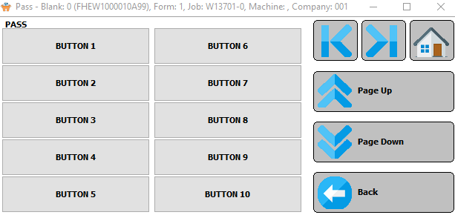

If the machine selected is for a printing press for a job with multiple printing passes, the program will prompt with “***Pass Number***” button. For large combination jobs, the form number may not be displayed on the screen

Therefore, the operator may press the “***First Form***” button or the “***Last Form***” button to show more form numbers for this particular job number.

### Machine Transaction Data

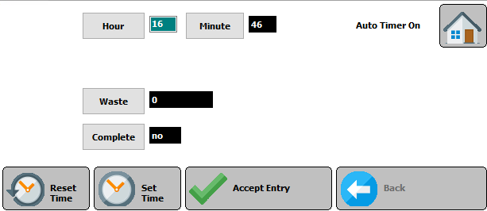

Once the machine, job number and form number have been selected, the first operation sequence for this machine will appear on the machine data collection screen. The manufacturing sequence should be defined in the machine file, therefore the normal manufacturing steps of set up, production run and subsequent cleanup are pre-defined so that the operator need not waste time entering these operation codes during machine data collection.

The top of the machine data collection screen shows the machine number, job number, the current manufacturing step, the form number as well as the pass number for jobs with multiple printing presses passes. If any information at the top of the screen is incorrect, the operator should press the ***“Exit”*** button to exit the screen and select the proper job information.

#### Time

The first fields for user input on the selected job Machine Data screen shows the current time of the day represented by the ***“HOUR”***, and ***“MINUTE”*** buttons.

Please Note: The format for these times are in *Military (24-Hour)* Time.

The current time of the day will appear automatically from the time set on the computer network server; however, the operator may press any of the time buttons to change either the hours or minutes.

#### Waste

Click the ***“Waste”*** button to enter any waste for this job transaction.

#### Complete

Press the ***“Complete”*** button to toggle this job transaction completion status between *Yes* and *No*.

#### Reset Time

Click the ***“Reset Time”*** button to reset the Hour and Minute fields to their last edited entries.

Please Note: If the user has made multiple changes before saving the time, this button will only reset the time back to the last-edited numbers, not the initial time that this screen was opened.

#### Accept Entry

Click the ***“Accept Entry”*** button to complete this operation. A confirmation popup screen will appear to ask the user to confirm that they wish to complete the operation.

## Machine Data Collection Auditing

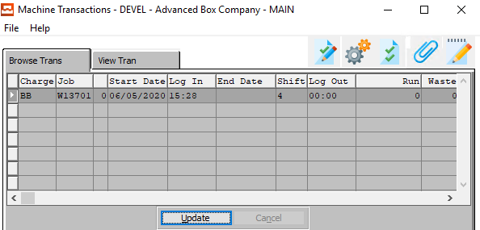

When the selected Job’s Machine Data screen pops up, it is accompanied the *Machine Transactions* screen. This screen shows the audit trail of all machine transactions performed for this job, which is represented by a “***Machine Browser”.***

### Browse Transactions

This browser shows the labor charge code, starting date, log in time, date finished, log out time, shift, total hours, quantity produced and quantity of waste for each process.

The operator may change the data of any transaction by double clicking any highlighted transaction. This will transfer the operator to the view transaction screen, which will allow the operator to update the transaction.

The *Browse* screen allows the user to update or view the currently selected transaction. If the user wishes to make changes, they should click the ***“Update”*** button with the desired transaction highlighted within the list of transactions.

If the user wishes to view more detailed information about a transaction, they should first make sure that the transaction they wish to view, then click on the *View Tran* tab.

#### Transactions Competed After Midnight

If a Job Run is started late on one day, and finished on the next day, the Advantzware Touch Screen software automatically creates two lines. The first of these transactions lines will end one minute before midnight, and as the system uses military time, will be set to 23:59.

The software code then adds a second line, starting the transaction at midnight (0:00), and ending the time at the true entered transaction end time.

In summary, the dates are automatically created so that data collection reports can be printed by their proper date ranges.

### View Transaction

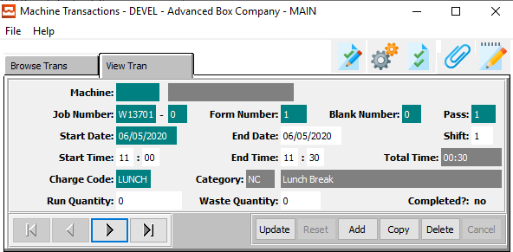

#### UPDATE

To change the currently selected Machine Transaction, simply click the ***“Update***” button at the bottom of the screen.

#### ADD

Click the ***“Add”*** button at the bottom of the screen to add a new Machine Transaction.

#### COPY

Click the ***“Copy”*** button to copy information from the currently selected Machine Transaction.

#### DELETE

To delete the currently selected Machine Transaction, simply press the ***"D"*** key. Alternatively, click the ***“Delete”*** button at the bottom of the screen.

#### NEXT

Press ***"N"*** (Next) to find next Machine Transaction to view or modify. Alternatively, press the ***“Right Arrow”*** on the screen.

#### PREVIOUS

Press ***"P"*** (Previous) to find previous Machine Transaction to view or modify. Alternatively, press the ***“Left Arrow”*** on the screen.

### Add/Update Transaction

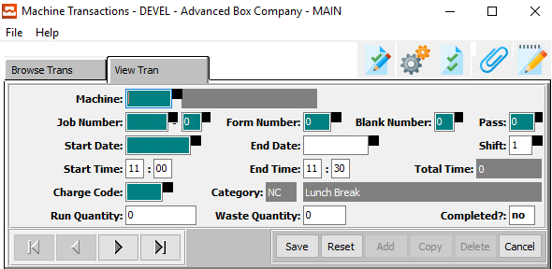

#### SAVE

Click the ***“Save”*** button to save all changes to the current Machine Transaction.

#### RESET

Click the ***“Reset”*** button to reset all fields to their original state.

#### CANCEL

Click the ***“Cancel”*** button to cancel all changes to the Machine Transaction without saving.

#### NEXT

Press ***"N"*** (Next) to find next Machine Transaction to view or modify. Alternatively, press the ***“Right Arrow”*** on the screen.

#### PREVIOUS

Press ***"P"*** (Previous) to find previous Machine Transaction to view or modify. Alternatively, press the ***“Left Arrow”*** on the screen.

### Add/Update Transaction Field Definitions

#### Machine

Enter the machine code for this Machine Transaction. Alternatively, the user may press the ***“F1”*** key to choose a code from a list of valid Machine Codes.

Once the user has entered or selected a valid machine code, the machine name field will automatically populate.

#### Job Number

Enter the job number for this Machine Transaction. Alternatively, the user may press the ***“F1”*** key to choose a number from a list of valid job numbers.

#### Job Number: 00

Enter the subsequent job number for this Machine Transaction, if applicable.

#### Form Number

Enter the number for the current form for this Machine Transaction.

#### Blank Number

Enter the number for the current blank for this Machine Transaction.

#### Pass Number

Enter the number for the current pass for this Machine Transaction.

#### Start Date / End Date

Enter the starting and ending dates for this Machine Transaction.

#### Shift

Enter the shift number for this Machine Transaction.

#### Start Time / End Time

Enter the starting and ending times for this Machine Transaction.

#### Charge Code

Enter the charge code for this Machine Transaction. Alternatively, the user may press the ***“F1”*** key to choose a code from a list of valid Job Codes.

#### Run Quantity

Enter the run quantity for this Machine Transaction.

#### Waste Quantity

Enter the waste quantity for this Machine Transaction.

#### Completed?

The user may toggle this Job as complete or incomplete by entering a ‘*yes*’ or a ‘*no*’ in this field.

## Employee Status

The ***“Employee Status”*** button may be utilized to view the status of an employee.

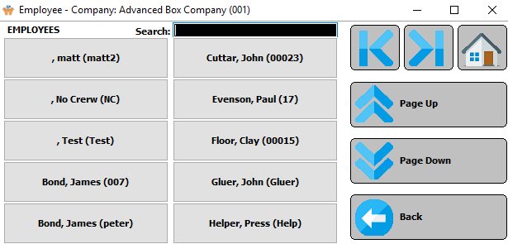

Once the ***“Employee Button”*** is pressed, a list of employees that are currently logged into a machine are shown on the screen. Press the ***“Next”***, ***“Previous”***, ***“Page Up”***, or ***“Page Down”*** buttons to navigate through the list of employees.

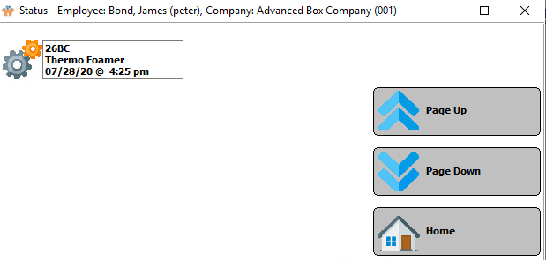

Once the employee is selected, the current machine that the employee is running is listed along with the date that the current transaction started.

Please Note: If the desired job is not shown on the screen, the operator may press the ***“Page Up”*** / ***“Page Down”*** buttons to select more jobs.

## Machine Status

Once employees log into a machine, the “***Machine Status***” button may be utilized to view all the status of all the employees currently running a particular machine.

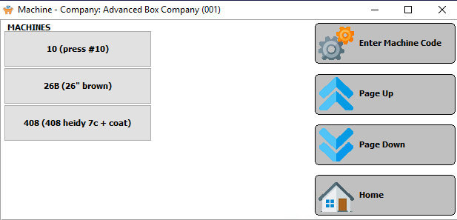

Once the “***Machine Status*** button is pressed, a list of machines that are currently running are shown on the screen. Press the ***“Page Up” / “Page Down”*** buttons to navigate through the list of machines.

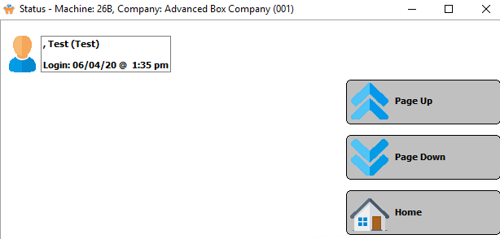

Once the Machine is selected, the current list of employees working on the machine are displayed along with the time and date that each employee started work on that machine.

## Job Checklist

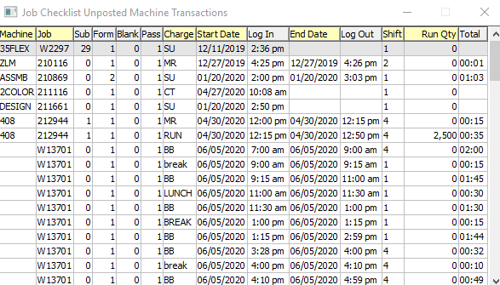

The *Job Checklist* screen allows the user to quickly review all currently unposted machine transactions.

# **Post Touch Data to ASI Database [TP]**

Once the machine data collection has been entered and the audit trail analyzed for accuracy, the job information must be posted in order to transfer to the Advantzware database. Once posted the transactions are removed from the active audit trail, however the posted transactions may be reviewed at any time via the posted transaction history file.

Machine transactions may be posted by company number, for a specific machine, a range of machines, for a range of dates and a range of shifts.

This will transfer the machine transactions to the Advantzware plant data collection file, however this file may be reviewed or updated prior to posting to the Job Cost files. This will not move the employee transactions to the Advantzware database; therefore, this history must be reviewed in the employee transaction files of the Touch Sensitive Data Collection module.

### Selection Parameters

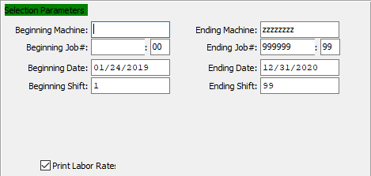

#### Beginning Machine / Ending Machine

Enter the beginning and ending machine Code to Post Data for.

#### Beginning Job # / Ending Job #

Enter the beginning and ending Job Number to Post Data for.

#### Beginning Job #: 00 / Ending Job #: 00

Enter the beginning and ending subsequent job number to Post Data for.

#### Beginning Date / Ending Date

Enter the beginning and ending date to Post Data for.

#### Beginning Shift / Ending Shift

Enter the beginning and ending Shift Number to Post Data for.

#### Print Labor Rate – Toggle Box

To print the labor rate on the report, make sure that the Print Labor Rate toggle box is checked.

### Output Destination

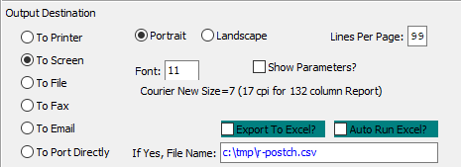

#### Destination Choice

To choose the destination where the document should be printed, please make sure that desired output destination choice bubble is toggled.

#### Layout Choice

To choose the preferred layout of Landscape vs. Portrait, please make sure the desired option choice bubbled is toggled.

#### Lines Per Page

Lines per page on the report when printing.

#### Font

Enter the font number to use with this report (Font 11 is default).

#### Show Parameters? – Toggle Box

To show parameters, make sure that the toggle box is ‘ticked’ with a checkmark.

#### Export to Excel? – Toggle Box

To export the printed file to an excel document, make sure that the Export to Excel toggle box is checked.

#### Auto Run Excel? – Toggle Box

To automatically open the new excel document, make sure that the Auto Run Excel toggle box is checked.

#### If Yes, File Name

If exporting the file to Excel, enter the desired file name.

# **Reports for Touch Screen [TR]**

## Daily Summary by Employee [TR1]

The daily summary by employee report should be printed to view the employee timecards including the beginning and ending time for each shift, as well as the starting and ending time or each job. The report may be run for any company, employee, job and a range. The report shows the date and time of each employee including the employee number, employee name, machine code, general ledger expense account number, transaction date and the time started.

To exit the report, press the ***“X”*** at the top of the right-hand corner of the screen or press the ***“Cancel”*** button at the bottom of the screen.

### Selection Parameters

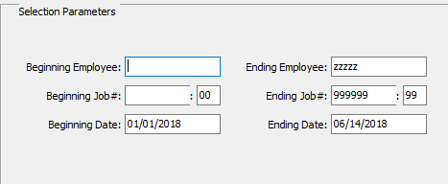

#### Beginning Employee / Ending Employee

Enter the beginning and ending Employee Number to run the daily summary report for.

#### Beginning Job # / Ending Job #

Enter the beginning and ending Job Number to run the daily summary report for.

#### Beginning Job #: 00 / Ending Job #: 00

Enter the beginning and ending Subsequent Job Number to run the daily summary report for.

#### Beginning Date / Ending Date

Enter the beginning and ending Date to run the daily summary report for.

### Output Destination

The report may be printed to the screen, to any printer on the network or to a file. The ***“Export to Excel”*** toggle box at the bottom of the screen may be used to save the report with any filename that the user chooses. The *FONT* field will allow the user to select which size letters to print the report. However, the report will print in alignment when using the eleven-point font.

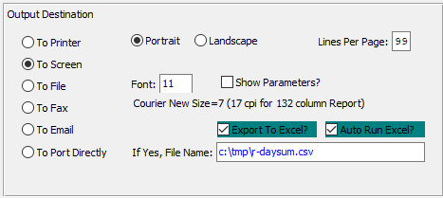

#### Destination Choice

To choose the destination where the document should be printed, please make sure that desired output destination choice bubble is toggled.

#### Layout Choice

To choose the preferred layout of Landscape vs. Portrait, please make sure the desired option choice bubbled is toggled.

#### Lines Per Page

Lines per page on the report when printing.

#### Font

Enter the font number to use with this report (Font 11 is default).

#### Show Parameters? – Toggle Box

To show parameters, make sure that the toggle box is ‘ticked’ with a checkmark.

#### Export to Excel? – Toggle Box

To export the printed file to an excel document, make sure that the Export to Excel toggle box is checked.

#### Auto Run Excel? – Toggle Box

To automatically open the new excel document, make sure that the Auto Run Excel toggle box is checked.

#### If Yes, File Name

If exporting the file to Excel, enter the desired file name.

## Employees List [TR2]

The employee list report should be printed to view the current list of employees. The report may be run for any company, an employee number range, employee last name range or social security number range.

The report has additional printing options which are enabled by checking the boxes in the lower right-hand corner of the screen titled; show employee rates, show log in/ log out transactions, show assigned machines. By selecting one of these boxes, the report will list the requested information. To show the print selections on the report, the user must select the parameter button.

The top of the report shows the date and time that the report was run, report name, the program name, the user ID who ran the report and the page number. The detail portion of the report shows the employee number, employee's name, employee type, general ledger account number, the date the employee started and any reference.

To exit the report, press the ***“X”*** at the top of the right-hand corner of the screen or press the ***“Cancel”*** button at the bottom of the screen.

### Selection Parameters

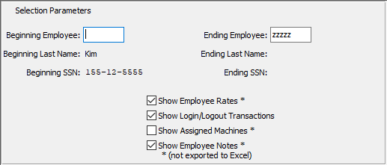

#### Beginning Employee / Ending Employee

Enter the beginning and ending Employee Number to run the employee list for.

#### Show Employee Rates – Toggle Box

To show employee rates on the employee reports, make sure that this toggle box is checked.

#### Show Login/Logout Transactions – Toggle Box

To show employee login and logout transactions on the employee reports, make sure that this toggle box is checked.

#### Show Assigned Machines – Toggle Box

To show an employees’ assigned machines on the employee reports, make sure that this toggle box is checked.

#### Show Employee Notes – Toggle Box

To show any employee notes on the report, make sure that this toggle box is checked.

### Output Destination

The report may be printed to the screen, to any printer on the network or to a file. The ***“Export to Excel”*** toggle box at the bottom of the screen may be used to save the report with any filename that the user chooses. The *FONT* field will allow the user to select which size letters to print the report. However, the report will print in alignment when using the eleven-point font.

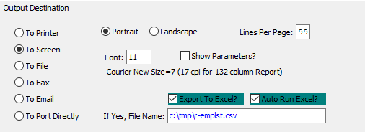

#### Destination Choice

To choose the destination where the document should be printed, please make sure that desired output destination choice bubble is toggled.

#### Layout Choice

To choose the preferred layout of Landscape vs. Portrait, please make sure the desired option choice bubbled is toggled.

#### Lines Per Page

Lines per page on the report when printing.

#### Font

Enter the font number to use with this report (Font 11 is default).

#### Show Parameters? – Toggle Box

To show parameters, make sure that the toggle box is ‘ticked’ with a checkmark.

#### Export to Excel? – Toggle Box

To export the printed file to an excel document, make sure that the Export to Excel toggle box is checked.

#### Auto Run Excel? – Toggle Box

To automatically open the new excel document, make sure that the Auto Run Excel toggle box is checked.

#### If Yes, File Name

If exporting the file to Excel, enter the desired file name.

## Machine Transactions [TR3]

The Machine Transactions List shows a daily summary by machine transactions, which have not been posted to the Advantzware database. The report may be printed for any company and for any range of machines. In addition, the report will also list the details of the employee transactions. To show the employee transactions, the user must mark the box called show employee transactions on the print screen. The report could be printed to view only the machines daily transactions.

To show the print selections on the report, the user must select the parameter button. The top of the report shows the date and time that the report was run, report name, the program name, the user ID who ran the report and the page number. The detail portion of the report shows the machine number, job number, form number, printing pass number, starting date, log in time, ending date, log out time, shift number, total hours, quantity produced while running and the quantity wasted.

To exit the report, press the ***“X”*** at the top of the right-hand corner of the screen or press the ***“Cancel”*** button at the bottom of the screen.

### Selection Parameters

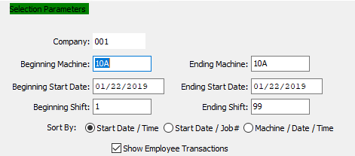

#### Company

Enter the company code.

#### Beginning Machine / Ending Machine

Enter the beginning and ending Machine Code to list transactions for.

#### Beginning Start Date / Ending Start Date

Enter the beginning and ending Date to list transactions for.

#### Beginning Shift / Ending Shift

Enter the beginning and ending Shift Number to list transactions for.

#### Sort By (Choice)

To choose the preferred sorting method, please make sure the desired option choice bubble is toggled.

#### Show Employee Transactions – Toggle Box

To show employee transactions for the machine transactions, make sure that the Show Employee Transactions toggle box is checked.

### Output Destination

The report may be printed to the screen, to any printer on the network or to a file. The ***“Export to Excel”*** toggle box at the bottom of the screen may be used to save the report with any filename that the user chooses. The *FONT* field will allow the user to select which size letters to print the report. However, the report will print in alignment when using the eleven-point font.

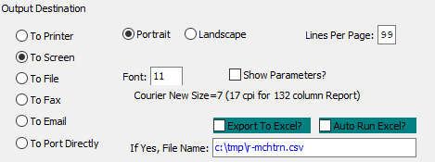

#### Destination Choice

To choose the destination where the document should be printed, please make sure that desired output destination choice bubble is toggled.

#### Layout Choice

To choose the preferred layout of Landscape vs. Portrait, please make sure the desired option choice bubbled is toggled.

#### Lines Per Page

Lines per page on the report when printing.

#### Font

Enter the font number to use with this report (Font 11 is default).

#### Show Parameters? – Toggle Box

To show parameters, make sure that the toggle box is ‘ticked’ with a checkmark.

#### Export to Excel? – Toggle Box

To export the printed file to an excel document, make sure that the Export to Excel toggle box is checked.

#### Auto Run Excel? – Toggle Box

To automatically open the new excel document, make sure that the Auto Run Excel toggle box is checked.

#### If Yes, File Name

If exporting the file to Excel, enter the desired file name.

## Completed Machine Jobs List [TR4]

The Completed Machine Job List shows a list of job numbers with the machine number representing completed operations. The report may be printed for any company or any range of machines. To show the print selections on the report, the user must select the parameter button.

The top of the report shows the date and time that the report was run, report name, the program name, the user ID who ran the report and the page number. The detail portion of the report shows the machine number and the job number.

To exit the report, press the ***“X”*** at the top of the right-hand corner of the screen or press the ***“Cancel”*** button at the bottom of the screen.

### Selection Parameters

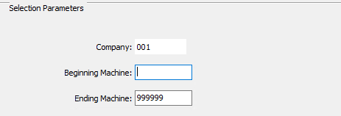

#### Company

Enter the company code.

#### Beginning Machine / Ending Machine

Enter the beginning and ending Machine Code to list completed jobs for.

### Output Destination

The report may be printed to the screen, to any printer on the network or to a file. The ***“Export to Excel”*** toggle box at the bottom of the screen may be used to save the report with any filename that the user chooses. The *FONT* field will allow the user to select which size letters to print the report. However, the report will print in alignment when using the eleven-point font.

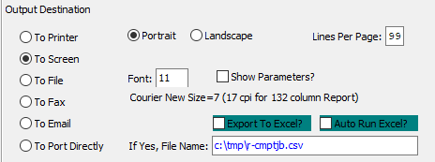

#### Destination Choice

To choose the destination where the document should be printed, please make sure that desired output destination choice bubble is toggled.

#### Layout Choice

To choose the preferred layout of Landscape vs. Portrait, please make sure the desired option choice bubbled is toggled.

#### Lines Per Page

Lines per page on the report when printing.

#### Font

Enter the font number to use with this report (Font 11 is default).

#### Show Parameters? – Toggle Box

To show parameters, make sure that the toggle box is ‘ticked’ with a checkmark.

#### Export to Excel? – Toggle Box

To export the printed file to an excel document, make sure that the Export to Excel toggle box is checked.

#### Auto Run Excel? – Toggle Box

To automatically open the new excel document, make sure that the Auto Run Excel toggle box is checked.

#### If Yes, File Name

If exporting the file to Excel, enter the desired file name.

## Shifts List [TR5]

The Shifts List shows a list of shift numbers, shift description and shift times, which have been established for all machines in the plant. The shifts are created in the shift file, whereby each machine can have its own shift times, hence different departments may have different start and stop times for each shift. The report may be printed for any company or any range of shifts.

To show the print selections on the report, the user must select the parameter button. The top of the report shows the date and time that the report was run, report name, the program name, the user ID who ran the report and the page number. The detail portion of the report shows the shift number, shift description, start time and ending time.

To exit the report, press the ***“X”*** at the top of the right-hand corner of the screen or press the ***“Cancel”*** button at the bottom of the screen.

### Selection Parameters

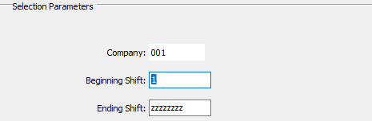

#### Company

Enter the company code.

#### Beginning Shift / Ending Shift

Enter the beginning and ending Shift Number to runs a shift list for.

### Output Destination

The report may be printed to the screen, to any printer on the network or to a file. The ***“Export to Excel”*** toggle box at the bottom of the screen may be used to save the report with any filename that the user chooses. The *FONT* field will allow the user to select which size letters to print the report. However, the report will print in alignment when using the eleven-point font.

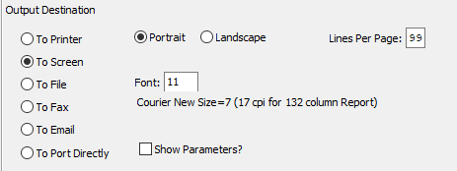

#### Destination Choice

To choose the destination where the document should be printed, please make sure that desired output destination choice bubble is toggled.

#### Layout Choice

To choose the preferred layout of Landscape vs. Portrait, please make sure the desired option choice bubbled is toggled.

#### Lines Per Page

Lines per page on the report when printing.

#### Font

Enter the font number to use with this report (Font 11 is default).

#### Show Parameters? – Toggle Box

To show parameters, make sure that the toggle box is ‘ticked’ with a checkmark.

#### Export to Excel? – Toggle Box

To export the printed file to an excel document, make sure that the Export to Excel toggle box is checked.

#### Auto Run Excel? – Toggle Box

To automatically open the new excel document, make sure that the Auto Run Excel toggle box is checked.

#### If Yes, File Name

If exporting the file to Excel, enter the desired file name.

## Machine Assigned Charge Codes [TR6]

The machine assigned charge code report shows all of the assigned labor transaction codes, which each machine will record during the production process. The report may be printed for any company or any range of machines.

To show the print selections on the report, the user must select the parameter button. The top of the report shows the date and time that the report was run, report name, the program name, the user ID who ran the report and the page number. The detail portion of the report shows the machine number, machine name, sequence number, charge code, charge category and description of the charge.

The charge code category included are make ready, run, down time charged to a job and down time does not charge to a job, which are created by Advanced Software only in the Advantzware database. The labor charge codes are defined in the machine charge code file of the Advantzware system, however unique charge codes may be added for each machine in the touch screen file maintenance machine assigned charge code file.

To exit the report, press the ***“X”*** at the top of the right-hand corner of the screen or press the ***“Cancel”*** button at the bottom of the screen.

### Selection Parameters

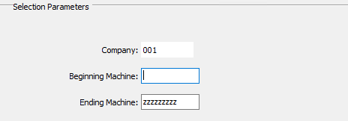

#### Company

Enter the company code.

#### Beginning Machine / Ending Machine

Enter the beginning and ending Machine Code to list machine assigned charge codes for.

### Output Destination

The report may be printed to the screen, to any printer on the network or to a file. The ***“Export to Excel”*** toggle box at the bottom of the screen may be used to save the report with any filename that the user chooses. The *FONT* field will allow the user to select which size letters to print the report. However, the report will print in alignment when using the eleven-point font.

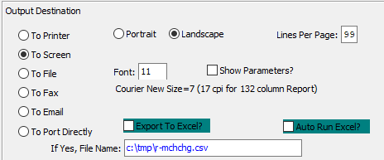

#### Destination Choice

To choose the destination where the document should be printed, please make sure that desired output destination choice bubble is toggled.

#### Layout Choice

To choose the preferred layout of Landscape vs. Portrait, please make sure the desired option choice bubbled is toggled.

#### Lines Per Page

Lines per page on the report when printing.

#### Font

Enter the font number to use with this report (Font 11 is default).

#### Show Parameters? – Toggle Box

To show parameters, make sure that the toggle box is ‘ticked’ with a checkmark.

#### Export to Excel? – Toggle Box

To export the printed file to an excel document, make sure that the Export to Excel toggle box is checked.

#### Auto Run Excel? – Toggle Box

To automatically open the new excel document, make sure that the Auto Run Excel toggle box is checked.

#### If Yes, File Name

If exporting the file to Excel, enter the desired file name.

## Machine Assigned Shifts List [TR7]

The Shifts List shows a list of assigned shift numbers for each machine including the shift description and shift times, which have been established for the machine. The shifts are created in the shift file, whereby each machine can have its own shift times, hence different departments may have different start and stop times for each shift. The report may be printed for any company or any range of machines.

To show the print selections on the report, the user must select the parameter button. The top of the report shows the date and time that the report was run, report name, the program name, the user ID who ran the report and the page number. The detail portion of the report shows the machine number, machine description, shift number, shift description, start time and ending time.

To exit the report, press the ***“X”*** at the top of the right-hand corner of the screen or press the ***“Cancel”*** button at the bottom of the screen.

### Selection Parameters

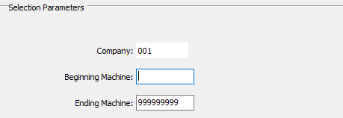

#### Company

Enter the company code.

#### Beginning Machine / Ending Machine

Enter the beginning and ending Machine Code to run an assigned shift list for.

### Output Destination

The report may be printed to the screen, to any printer on the network or to a file. The ***“Export to Excel”*** toggle box at the bottom of the screen may be used to save the report with any filename that the user chooses. The *FONT* field will allow the user to select which size letters to print the report. However, the report will print in alignment when using the eleven-point font.

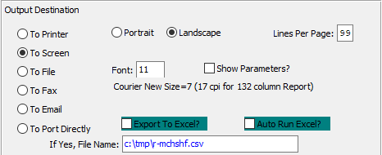

#### Destination Choice

To choose the destination where the document should be printed, please make sure that desired output destination choice bubble is toggled.

#### Layout Choice

To choose the preferred layout of Landscape vs. Portrait, please make sure the desired option choice bubbled is toggled.

#### Lines Per Page

Lines per page on the report when printing.

#### Font

Enter the font number to use with this report (Font 11 is default).

#### Show Parameters? – Toggle Box

To show parameters, make sure that the toggle box is ‘ticked’ with a checkmark.

#### Export to Excel? – Toggle Box

To export the printed file to an excel document, make sure that the Export to Excel toggle box is checked.

#### Auto Run Excel? – Toggle Box

To automatically open the new excel document, make sure that the Auto Run Excel toggle box is checked.

#### If Yes, File Name

If exporting the file to Excel, enter the desired file name.

## Employee Types List [TR8]

The employee list report should be printed to view the current list of employee types. The employee types are created in the employee type file for creating types such as full-time hourly, full-time salary, part time and temporary. The report may be run for any company, an employee type range or an employee type description range.

To show the print selections on the report, the user must select the parameter button. The top of the report shows the date and time that report was run, the report name, program name, the user ID who ran the report and the page number. The detail portion of the report shows the employee type and employee type description.

To exit the report, press the ***“X”*** at the top of the right-hand corner of the screen or press the ***“Cancel”*** button at the bottom of the screen.

### Selection Parameters

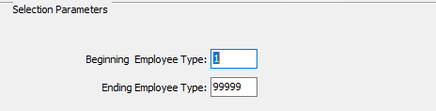

#### Beginning Employee Type / Ending Employee Type

Enter the beginning and ending Employee Type to run the report for.

### Output Destination

The report may be printed to the screen, to any printer on the network or to a file. The ***“Export to Excel”*** toggle box at the bottom of the screen may be used to save the report with any filename that the user chooses. The *FONT* field will allow the user to select which size letters to print the report. However, the report will print in alignment when using the eleven-point font.

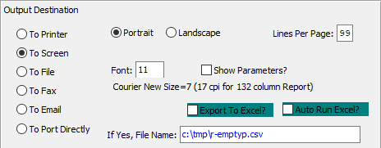

#### Destination Choice

To choose the destination where the document should be printed, please make sure that desired output destination choice bubble is toggled.

#### Layout Choice

To choose the preferred layout of Landscape vs. Portrait, please make sure the desired option choice bubbled is toggled.

#### Lines Per Page

Lines per page on the report when printing.

#### Font

Enter the font number to use with this report (Font 11 is default).

#### Show Parameters? – Toggle Box

To show parameters, make sure that the toggle box is ‘ticked’ with a checkmark.

#### Export to Excel? – Toggle Box

To export the printed file to an excel document, make sure that the Export to Excel toggle box is checked.

#### Auto Run Excel? – Toggle Box

To automatically open the new excel document, make sure that the Auto Run Excel toggle box is checked.

#### If Yes, File Name

If exporting the file to Excel, enter the desired file name.

## Labor Report [TR9]

### Selection Parameters

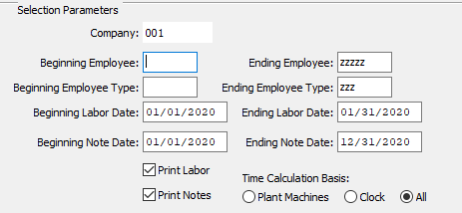

#### Company

Enter the company code.

#### Beginning Employee / Ending Employee

Enter the beginning and ending Employee Code to run the labor report for.

#### Beginning Employee Type / Ending Employee Type

Enter the beginning and ending Employee Type to run the labor report for.

#### Beginning Labor Date / Ending Labor Date

Enter the beginning and ending Labor Date to run the labor report for.

#### Beginning Note Date / Ending Note Date

Enter the beginning and ending Note Date to run the labor report for.

#### Print Labor – Toggle Box

To print the labor date and rates, make sure that the Print Labor toggle box is checked.

#### Print Notes – Toggle Box

To print any notes, make sure that the Print Notes toggle box is checked.

#### Time Calculation Basis (Choice)

To choose the preferred time calculation basis of Plant Machines vs. Clock (Or All), please make sure the desired option choice bubble is toggled.

### Output Destination

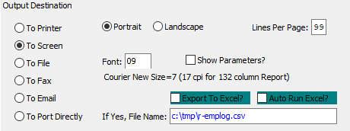

#### Destination Choice

To choose the destination where the document should be printed, please make sure that desired output destination choice bubble is toggled.

#### Layout Choice

To choose the preferred layout of Landscape vs. Portrait, please make sure the desired option choice bubbled is toggled.

#### Lines Per Page

Lines per page on the report when printing.

#### Font

Enter the font number to use with this report (Font 11 is default).

#### Show Parameters? – Toggle Box

To show parameters, make sure that the toggle box is ‘ticked’ with a checkmark.

#### Export to Excel? – Toggle Box

To export the printed file to an excel document, make sure that the Export to Excel toggle box is checked.

#### Auto Run Excel? – Toggle Box

To automatically open the new excel document, make sure that the Auto Run Excel toggle box is checked.

#### If Yes, File Name

If exporting the file to Excel, enter the desired file name.

## Employee Time by Job and Machine [TR)]

### Selection Parameters

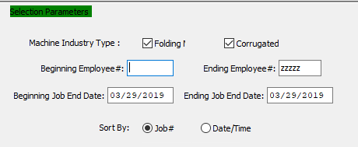

#### Folding – Toggle Box

To include folding boxes in the report, make sure that the Folding toggle box is checked.

#### Corrugated – Toggle Box

To include corrugated boxes in the report, make sure that the Corrugated toggle box is checked.

#### Beginning Employee # / Ending Employee #

Enter the beginning and ending Employee Number to run the employee time report for.

#### Beginning Job End Date / Ending Job End Date

Enter the beginning and ending Job End Date to run the employee time report for.

#### Sort By (Choice)

To choose the preferred sorting method of Job # vs. Date/Time, please make sure the desired option choice bubble is toggled.

### Output Destination

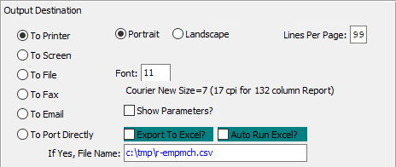

#### Destination Choice

To choose the destination where the document should be printed, please make sure that desired output destination choice bubble is toggled.

#### Layout Choice

To choose the preferred layout of Landscape vs. Portrait, please make sure the desired option choice bubbled is toggled.

#### Lines Per Page

Lines per page on the report when printing.

#### Font

Enter the font number to use with this report (Font 11 is default).

#### Show Parameters? – Toggle Box

To show parameters, make sure that the toggle box is ‘ticked’ with a checkmark.

#### Export to Excel? – Toggle Box

To export the printed file to an excel document, make sure that the Export to Excel toggle box is checked.

#### Auto Run Excel? – Toggle Box

To automatically open the new excel document, make sure that the Auto Run Excel toggle box is checked.

#### If Yes, File Name

If exporting the file to Excel, enter the desired file name.

## In/Out Transaction Report [TR!]

### Selection Parameters

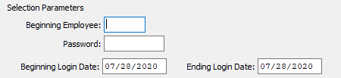

#### Beginning Employee

Enter the beginning employee number to run the transaction report for.

#### Password

Enter this employee’s password.

#### Beginning XXX / Ending XXX

Enter the beginning and ending Login Date to run the transaction report for.

### Output Destination

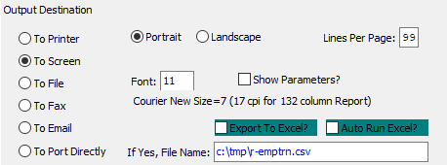

#### Destination Choice

To choose the destination where the document should be printed, please make sure that desired output destination choice bubble is toggled.

#### Layout Choice

To choose the preferred layout of Landscape vs. Portrait, please make sure the desired option choice bubbled is toggled.

#### Show Parameters? – Toggle Box

To show parameters, make sure that the toggle box is ‘ticked’ with a checkmark.

#### Export to Excel? – Toggle Box

To export the printed file to an excel document, make sure that the Export to Excel toggle box is checked.

#### Auto Run Excel? – Toggle Box

To automatically open the new excel document, make sure that the Auto Run Excel toggle box is checked.

#### If Yes, File Name

If exporting the file to Excel, enter the desired file name.

## Employee Time Sheet [TR@]

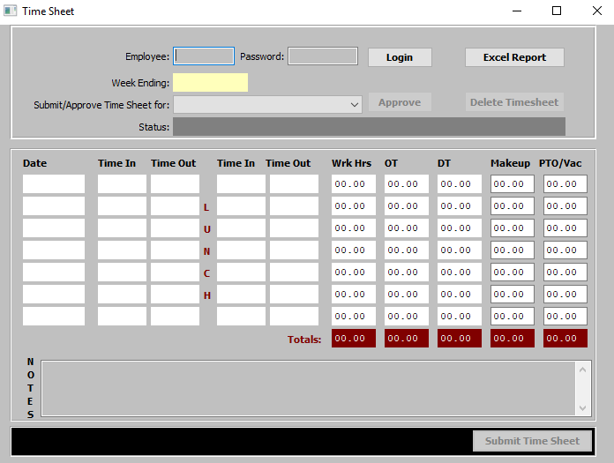

To view the time sheet for a specific employee, please enter the *Employee Number* and *Password* for the chosen employee.

## Unreported Labor Report [TR#]

### Selection Parameters

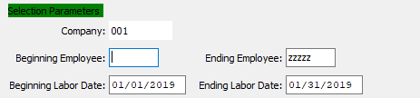

#### Company

Enter the company code.

#### Beginning Employee / Ending Employee

Enter the beginning and ending Employee Number to run the unreported labor report for.

#### Beginning Labor Date / Ending Labor Date

Enter the beginning and ending Labor Date to run the unreported labor report for.

### Time Calculation and Shifts

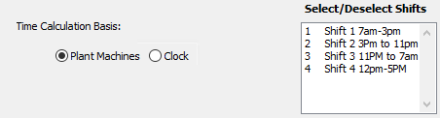

#### Time Calculation Basis (Choice)

To choose the preferred calculation basis of Plant Machines vs. Clock, please make sure the desired option choice bubble is toggled.

#### Select/Deselect Shifts

The user may select which reports they wish to include in the current Unreported Labor report. To select multiple reports, press the ***“Control”*** key while clicking the desired reports within the available report list. Selected reports will be highlighted, and only highlighted reports will be included in the Financial Statement report. To deselect reports, press the ***“Control”*** key while clicking already-highlighted selections.

### Output Destination

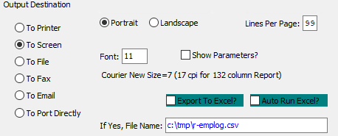

#### Destination Choice

To choose the destination where the document should be printed, please make sure that desired output destination choice bubble is toggled.

#### Layout Choice

To choose the preferred layout of Landscape vs. Portrait, please make sure the desired option choice bubbled is toggled.

#### Lines Per Page

Lines per page on the report when printing.

#### Font

Enter the font number to use with this report (Font 11 is default).

#### Show Parameters? – Toggle Box

To show parameters, make sure that the toggle box is ‘ticked’ with a checkmark.

#### Export to Excel? – Toggle Box

To export the printed file to an excel document, make sure that the Export to Excel toggle box is checked.

#### Auto Run Excel? – Toggle Box

To automatically open the new excel document, make sure that the Auto Run Excel toggle box is checked.

#### If Yes, File Name

If exporting the file to Excel, enter the desired file name.

## Machine Notes Report [TR$]

### Selection Parameters

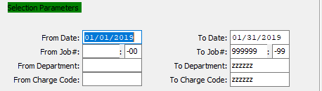

#### Beginning Date / Ending Date

Enter the beginning and ending Date to run the machine notes report for.

#### Beginning Job # / Ending Job #

Enter the beginning and ending Job Number to run the machine notes report for.

#### Beginning Job #: 00 / Ending Job #: 00

Enter the beginning and ending subsequent job number to run the machine notes report for.

#### Beginning Department / Ending Department

Enter the beginning and ending Department to run the machine notes report for.

#### Beginning Charge Code / Ending Charge Code

Enter the beginning and ending Charge Code to run the machine notes report for.

### Available and Selected Columns

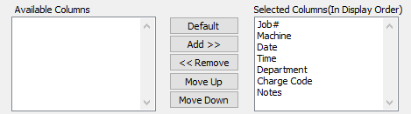

#### Available Columns

The user may choose which columns they wish to have on the report printout. As the user selects their choices, they will appear on the ‘*Selected Columns’* list.

#### Selected Columns (In Display Order)

The columns that the user has chosen from the ‘*Available Columns’* list. The order that these columns are displayed in here is the order in which they will print on the report.

#### Default

Click the ***“Default****”* button to sort the ‘*Selected Columns’* list by the default system parameters.

#### Add >>

Click on the selected item from the ‘*Available Columns’* list to highlight it, then click the ***“Add”*** button to add the selected column to the ‘*Selected Columns’* list.

#### << Remove

Click on the selected item from the ‘*Selected Columns’* list to highlight it, then click the ***“Remove”*** button to remove the selected column to the ‘*Selected Columns’* list.

#### Move Up

Within the ‘*Selected Columns’* list, the user may choose the order they wish the selected columns to print in. In order to change the order of the columns, the user can click on a selection to highlight it. By then clicking the ***“Move Up***” button, the user can change its position on the report.

#### Move Down

Within the ‘*Selected Columns’* list, the user may choose the order they wish the selected columns to print in. In order to change the order of the columns, the user can click on a selection to highlight it. By then clicking the ***“Move Down***” button, the user can change its position on the report.

### Output Destination

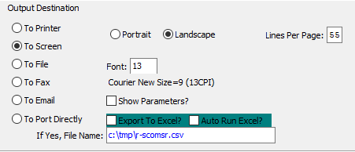

#### Destination Choice

To choose the destination where the document should be printed, please make sure that desired output destination choice bubble is toggled.

#### Layout Choice

To choose the preferred layout of Landscape vs. Portrait, please make sure the desired option choice bubbled is toggled.

#### Show Parameters? – Toggle Box

To show parameters, make sure that the toggle box is ‘ticked’ with a checkmark.

#### Export to Excel? – Toggle Box

To export the printed file to an excel document, make sure that the Export to Excel toggle box is checked.

#### Auto Run Excel? – Toggle Box

To automatically open the new excel document, make sure that the Auto Run Excel toggle box is checked.

#### If Yes, File Name

If exporting the file to Excel, enter the desired file name.

# **File Maintenance for Touch Screen [TF]**

## Employees [TF1]

### Browse Employees

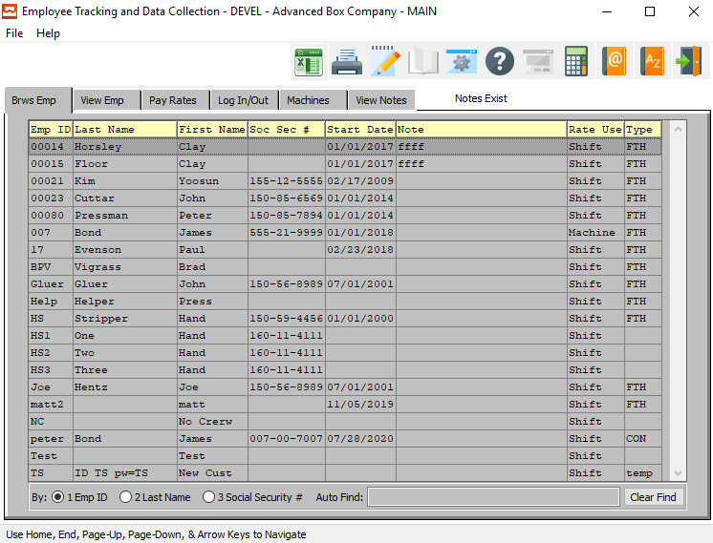

Prior to adding employees, the default employee rates, default company shifts, and default hourly labor rates should be created to speed the data entry process. The Employee Browser shows a list of employees which may be sorted by employee number, last name or social security number.

Once an employee record is highlighted on the screen, simply ***“Double-Click”*** with your mouse or press the ***“Enter”*** key to view or change the employee data. The browser is very similar to the “***F5”*** function key which Advantzware users may be familiar with using.

To sort by the employee ID, last name or social security number, simply check the appropriate field at the bottom of the browser and the list will be resorted in that order. To find a particular employee, the *Auto Find* search box at the bottom of the browser provides an alpha numeric search capability by typing a few characters and pressing the ***“Enter”*** key. The browser shows the employee ID, last name, first name, Social Security number, starting date, General ledger account number, the employee rate shift usage and the employee type.

The other folders listed on the employee browser screen provide the ability to add, change, delete and copy employee's, a rate log in times, log now times and machines which the employee is authorized to operate.

### Employee Phone Information: Browse Phone Directory

In order to view phone information for a specific Employee, the desired Employee must be selected within the list of all available Employees. The user may search for a specific Employee, or narrow down the browse list, by using the search fields located along the top of the page.

In order to select a specific Employee within the list to view detailed information for, the user must ensure that it is highlighted within the list. In order to highlight an Employee, the user may click on their desired Employee.

|  |  |
| --- | --- |
|  | To view phone information for the selected Employee, the user may now click on the ***“@ Pictured Address Book”*** at the top of the screen. |

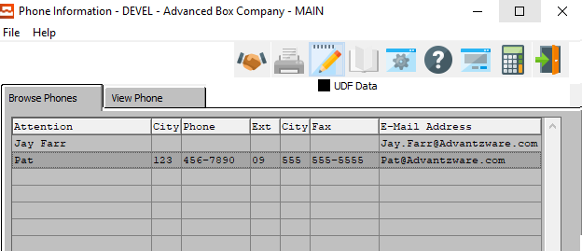

The Phone Browser shows a directory of employee's phone numbers, which are sorted along the attention line.

In order to view detailed information for a specific employee, the desired employee must be selected within the list of all available employees. The user may search for a specific employee, or narrow down the browse list, by using the *Auto Find* search field located at the bottom of the page.

In order to select a specific contact within the list to view detailed information for, the user must ensure that it is highlighted within the list. In order to highlight a contact, the user may click on their desired contact.

#### View Phone

Once the user has highlighted their desired contact to view detailed information for, they may click on the ***“View Phone”*** tab at the top of the screen. This tab allows the user to view detailed information, as well as update and add contacts.

#### Open Notes

Once the user has highlighted their desired contact to view detailed information for, they may click on the ***“Paper and Pencil Icon”*** button at the top of the screen. This button opens the Notes section for the highlighted contact, showing the user any notes specifically attached to that contact.

This will also allow the user to update and add notes for the designated contact.

### Employee Phone Information: View Phone Information

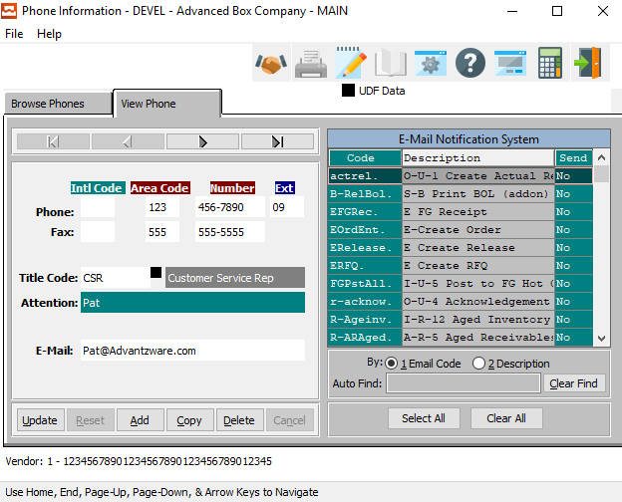

The ***“View Phone”*** screen shows the user detailed information about the selected Employee. In this screen, the user can update information about the current Employee, update the current Employee’s selected email notifications, or add a new Employee.

Many phone numbers may be created for an individual employee such as his home number, doctor's phone number, emergency phone number and more.

#### UPDATE

Click the ***“Update”*** button to update the current Employee’s information.

#### ADD

Click the ***“Add”*** button to add a new Employee for this customer.

#### COPY

Click the ***“Copy”*** button to copy information from the currently selected contact.

#### DELETE

Click the ***“Delete”*** button to delete the currently selected contact.

#### NEXT

Press ***"N"*** (Next) to find next Contact to view or modify. Alternatively, press the ***“Right Arrow”*** on the screen.

#### PREVIOUS

Press ***"P"*** (Previous) to find previous Contact to view or modify. Alternatively, press the ***“Left Arrow”*** on the screen.

### Add/Update Employee Phone Information

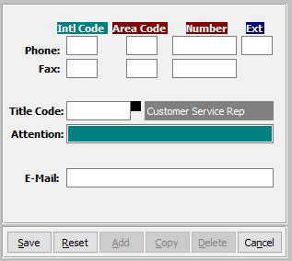

#### SAVE

Click the “***Save***” button to save the current Contact.

#### RESET

Click the “***Reset***” button to reset all changes to the Contact.

#### CANCEL

Click the “***Cancel***” button to cancel the Contact without saving changes.

### Add/Update Employee Phone Information Field Definitions

#### International Code - Phone

Enter the International Code for this contact’s phone number.

#### Area Code - Phone

Enter the Area Code for this contact’s phone number.

#### Phone Number

Enter this contact’s phone number.

#### Phone Extension

Enter this contact’s phone extension code.

#### International Code – Fax

Enter the International Code for this contact’s fax number.

#### Area Code – Fax

Enter the Area Code for this contact’s fax number.

#### Fax Number

Enter this contact’s fax number.

#### Title Code

Enter this contact’s Title Code. Alternatively, the user can press the ***“F1”*** key to choose a Title Code from a list of available codes.

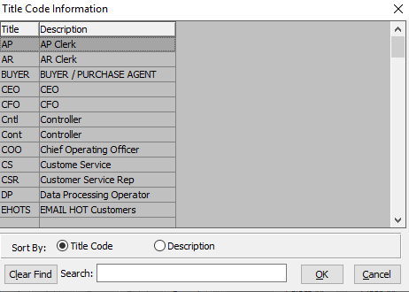

#### Attention

Enter the Contact’s Name.

#### E-Mail

Enter the e-mail address for this contact.

### Email Notification System Options

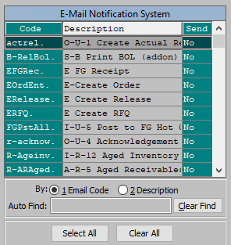

The *‘E-Mail Notification System’* allows the user to quickly choose which e-mails this Contact will receive from the Advantzware system. Contacts will only receive system emails that have their *“Send”* column set to ***“Yes”***.

In order to set the Contact up for a specific email notification, the user can search for their desired Email Code narrow down the browse list, by using the search field located at the bottom of the page.

In order to set a specific contact within the list to a ***“Yes”*** send option, the user must double-click the desired email code. This will set the email send option to ***“Yes”*** if it is currently ***“No”***, opting the Contact in for this specific email. Alternatively, double-clicking an email that currently has a send option of ***“Yes”*** will set it to ***“No”***, thus opting the contact out of receiving the selected email.

#### SELECT ALL

Clicking the ***“Select All”*** button will opt the user into receiving all the system emails currently available, setting all the Send Options to ***“Yes”***.

#### CLEAR ALL

Clicking the ***“Clear All”*** button will opt the user out of receiving all the system emails currently available, setting all the Send Options to ***“No”***.

### Employee Notes – Browse

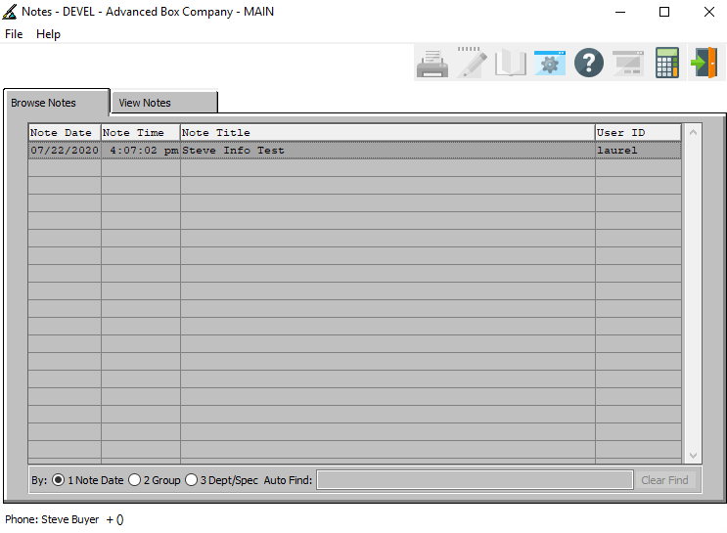

The *“Contact Notes”* screen allows a user to create an unlimited number of notes pertaining to the currently selected Contact. It keeps track of the note’s date and time so that the user can clean up old notes as necessary.

The *“Browse Notes”* screen shows the user the titles of all of the available notes for the currently selected contact. In order to view detailed notes for a specific contact, the desired note must be selected within the list of all available notes. The user may search for a specific note, or narrow down the browse list, by using the search field located at the bottom of the page.

In order to select a specific note within the list to view detailed information for, the user must ensure that it is highlighted within the list. In order to highlight a note, the user may click on their desired note.

### Employee Notes – View

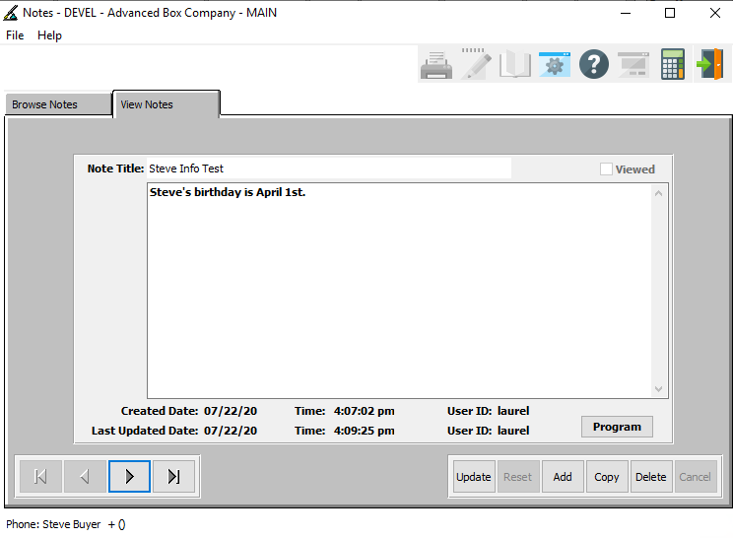

#### UPDATE

Click the ***“Update”*** button to update the currently selected Contact Note.

#### ADD

Click the ***“Add”*** button to add a new note for the current Contact.

#### COPY

Click the ***“Copy”*** button to copy information from the currently selected Contact Note.

#### DELETE

Click the ***“Delete”*** button to delete the currently selected Contact Note.

#### NEXT

Press ***"N"*** (Next) to find next Contact Note to view or modify. Alternatively, press the ***“Right Arrow”*** on the screen.

#### PREVIOUS

Press ***"P"*** (Previous) to find previous Contact Note to view or modify. Alternatively, press the ***“Left Arrow”*** on the screen.

### Add/Update Notes

#### SAVE

Click the “***Save***” button to save the current Contact Note.

#### RESET

Click the “***Reset***” button to reset all changes to the Contact Note.

#### CANCEL

Click the “***Cancel***” button to cancel the Contact Note without saving changes.

### Add/Update Notes Field Definitions

#### Note Title

The user may enter a short description of this note’s contents in this field.

#### Notes

The user may enter all the notes that they wish in this field.

### Employee Address Information: Browse Address Directory

In order to view address information for a specific Employee, the desired Employee must be selected within the list of all available Employees. The user may search for a specific Employee, or narrow down the browse list, by using the search fields located along the top of the page.

In order to select a specific Employee within the list to view detailed information for, the user must ensure that it is highlighted within the list. In order to highlight an Employee, the user may click on their desired Employee.

|  |  |
| --- | --- |
|  | To view phone information for the selected Employee, the user may now click on the ***“A/Z Pictured Address Book”*** at the top of the screen. |

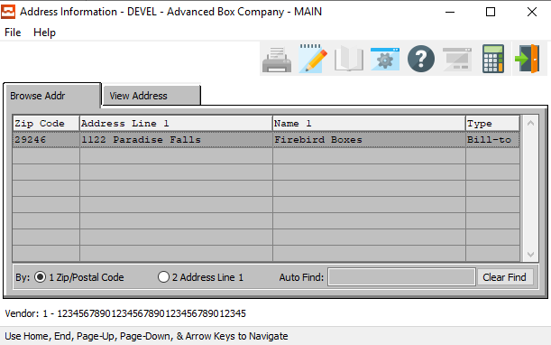

The *“Browse Address”* screen will show the user all of the available addresses for the selected Employee.

In order to view detailed information for a specific address, the desired address must be selected within the list of all available addresses. The user may search for a specific address, or narrow down the browse list, by using the search field located at the bottom of the page.

In order to select a specific address within the list to view detailed information for, the user must ensure that it is highlighted within the list. In order to highlight a address, the user may click on their desired address.

#### View Address

Once the user has highlighted their desired address to view detailed information for, they may click on the ***“View Address”*** tab at the top of the screen. This tab allows the user to view detailed information, as well as update and add addresses.

### Employee Address Information: View Address Information

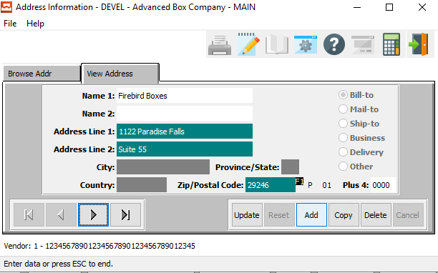

#### UPDATE

Click the ***“Update”*** button to update the currently selected Address.

#### ADD

Click the ***“Add”*** button to add a new note for the current Address.

#### COPY

Click the ***“Copy”*** button to copy information from the currently selected Address.

#### DELETE

Click the ***“Delete”*** button to delete the currently selected Address.

#### NEXT

Press ***"N"*** (Next) to find next Address to view or modify. Alternatively, press the ***“Right Arrow”*** on the screen.

#### PREVIOUS

Press ***"P"*** (Previous) to find previous Address to view or modify. Alternatively, press the ***“Left Arrow”*** on the screen.

### Add/Update Address

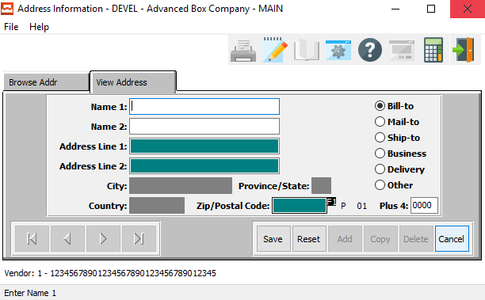

#### SAVE

Click the “***Save***” button to save the current Address.

#### RESET

Click the “***Reset***” button to reset all changes to the Address.

#### CANCEL

Click the “***Cancel***” button to cancel the Address without saving changes.

### Add/Update Address Field Definitions

#### Name 1

The user may enter the initial name for the Vendor at this address.

#### Name 2

The user may enter the secondary name for the Vendor at this address.

#### Address Line 1

The user may enter the initial address line for the Vendor at this address.

#### Address Line 2

The user may enter the secondary address line for the Vendor at this address.

#### Zip/Postal Code

The user may enter the valid zip code for this address. This code must come from the system list of available, valid Zip Codes. Alternatively, the user can press the ***“F1”*** button to choose a code from a list of available Zip/Postal codes.

Once the user has entered or chosen a valid Zip/Postal code, the City, State, and Country will automatically be updated by the system. The user cannot modify these fields here, as they are systematically linked to the valid Zip/Postal Code.

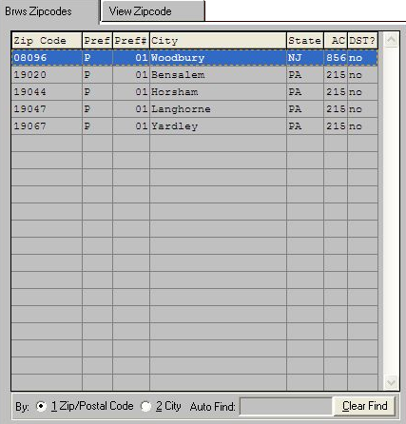

Please Note: If the user does not see their desired Zip/Postal code within this list, they must create a new zip code in the ***“N” – “C” – “6”*** (Zip Codes) system.

#### Plus 4

This field is for the last four digits of the Zip or Postal code.

#### Address Type (Choice)

To choose the preferred Address Type for this address, please make sure the desired option choice bubble is toggled.

### View Employees

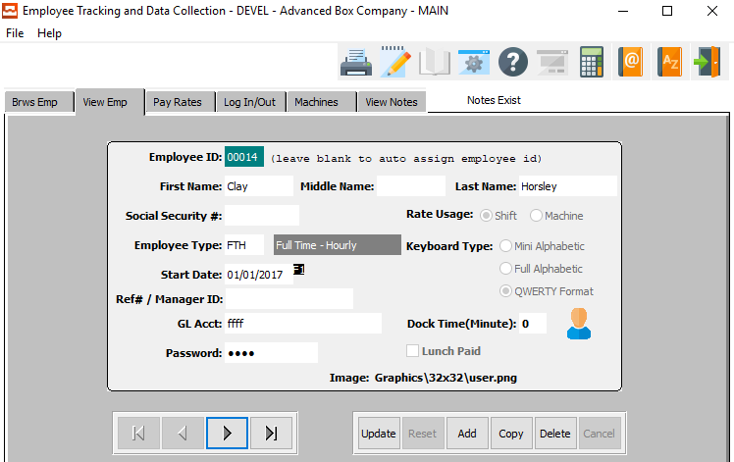

One major difference between our touch sensitive data collection module and the Advantzware data collection module is that this new program features employee tracking of hours and cost in addition to the machine time, which both products record. If your company does not want to track employee hours, then create an employee equal to the machine operation so that only one employee which will log into the machine code. There should be at least one employee per machine.

#### UPDATE

To change the currently selected Employee, simply click the ***“Update***” button at the bottom of the screen.

#### ADD

Click the ***“Add”*** button at the bottom of the screen to add a new Employee.

#### COPY

Click the ***“Copy”*** button to copy information from the currently selected Employee.

#### DELETE

To delete the currently selected Employee, simply press the ***"D"*** key. Alternatively, click the ***“Delete”*** button at the bottom of the screen.

#### NEXT

Press ***"N"*** (Next) to find next Employee to view or modify. Alternatively, press the ***“Right Arrow”*** on the screen.

#### PREVIOUS

Press ***"P"*** (Previous) to find previous Employee to view or modify. Alternatively, press the ***“Left Arrow”*** on the screen.

### Add/Update Employees

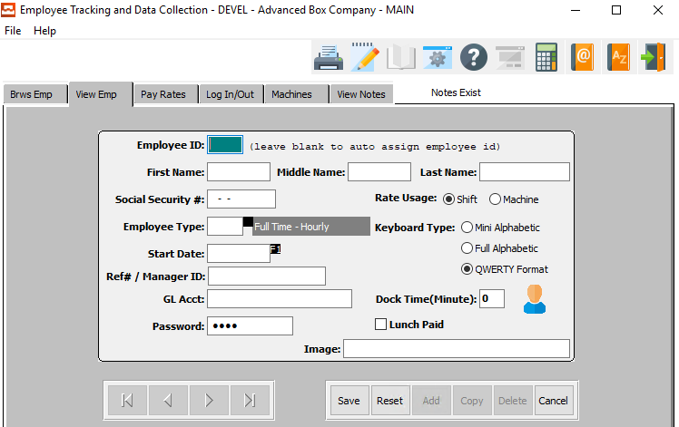

#### SAVE

Click the ***“Save”*** button to save all changes to the current Employee.

#### RESET

Click the ***“Reset”*** button to reset all fields to their original state.

#### CANCEL

Click the ***“Cancel”*** button to cancel all changes to the Employee without saving.

### Add/Update Employees Field Definitions

#### Employee ID

Enter a unique employee ID number into this field.

Please Note: The user should leave this field blank if they wish the system to automatically assign a unique ID number for this new employee.

#### Employee Name (First/Middle/Last)

Enter the employee’s first, middle, and last names into the respective fields.

#### Social Security #

Enter the employee’s social security number.

#### Employee Type

Enter the employee type in this field. Alternatively, the user may press the ***“F1”*** key to choose a type from a list of valid Employee Types.

Valid Employee Types are as Follows:

|  |  |  |  |
| --- | --- | --- | --- |
| CON | Contract | PT | Part Time |
| FTH | Full Time – Hourly | TEMP | Temporary |
| FTS | Full – Time Salaried |  |  |

#### Start Date

Enter this employee’s starting date.

#### Ref# / Manager ID

Enter this employee’s reference number or manager ID number.

#### GL Account

Enter this employee’s general ledger account number.

#### Password

Enter a unique password for this employee to use for their login and logout.

#### Rate Usage (Choice)

To choose the preferred rate usage for this employee of Shift vs. Machine, please make sure the desired option choice bubble is toggled.

#### Keyboard Type (Choice)

To choose the preferred keyboard type for this particular employee, please make sure the desired option choice bubble is toggled.

#### Dock Time (Minute)

Enter the number of minutes of dock time for this employee.

#### Lunch Paid – Toggle Box

To toggle this employee as eligible for paid lunch breaks, make sure that the Lunch Paid toggle box is checked.

#### Image

Enter the location of the employee image file to attach to this employee. Alternatively, press the ***“F1”*** key to use the Windows Explorer window to choose the proper file path.

### Pay Rates

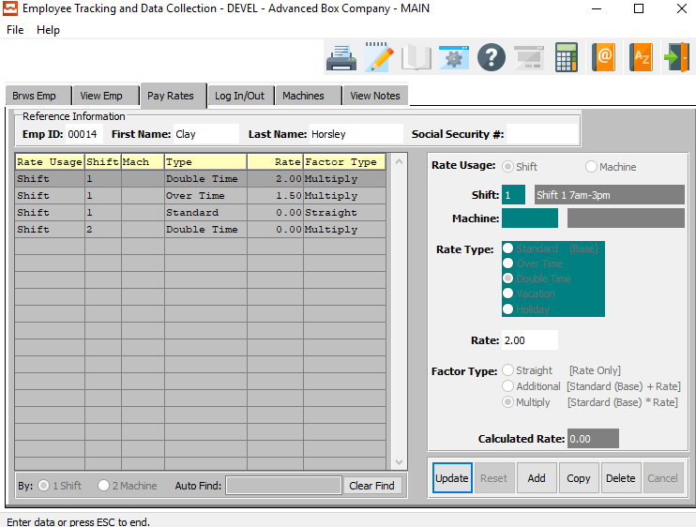

To add, change, delete, or view an employee's hourly or salary pay rates, the tab entitled ***“Pay Rates”*** must be selected after selecting an employee. The employees pay rate browser will list the existing pay rates showing the rate usage (i.e. by machine or shift), shift number, machine code, rate type, hourly rate and factor type description.

#### UPDATE

To change the currently selected Employee Pay Rate, simply click the ***“Update***” button at the bottom of the screen.

#### ADD

Click the ***“Add”*** button at the bottom of the screen to add a new Employee Pay Rate.

#### COPY

Click the ***“Copy”*** button to copy information from the currently selected Employee Pay Rate.

#### DELETE

To delete the currently selected Employee Pay Rate, simply press the ***"D"*** key. Alternatively, click the ***“Delete”*** button at the bottom of the screen.

### Add/Update Pay Rates

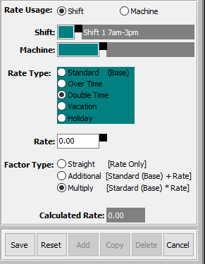

When adding or updating an hourly pay rate, many selections are available to help calculate the employees pay rate.

#### SAVE

Click the ***“Save”*** button to save all changes to the current Pay Rate.

#### RESET

Click the ***“Reset”*** button to reset all fields to their original state.

#### CANCEL

Click the ***“Cancel”*** button to cancel all changes to the Pay Rate without saving.

### Add/Update Pay Rates Field Definitions

#### Rate Usage (Choice)

The first field on the screen is the rate usage, which determines if the pay rate is for a particular machine or the pay rate is for the entire shift. If the employee has only one hourly rate for all machines that he operates, the rate usage should be set to ***shift***. If the employee is paid different hourly rates depending on the machine, the rate usage should be set to ***machine***.

To choose the preferred Rate Usage of Shift vs. Machine, please make sure the desired option choice bubble is toggled.

#### Shift

The shift field must be a valid shift defined in the shift file, therefore the “***F1”*** key may be used to display the valid shifts.

#### Machine

The machine code is required only if the rate usage field is set to machine, whereby the employee's hourly rate will be defined for each particular machine.

#### Rate Type (Choice)

The rate type field is used to differentiate different hourly rates for the same employee.

Available options are as follows:

|  |  |  |  |  |
| --- | --- | --- | --- | --- |
| Standard (Base) | Over Time | Double Time | Vacation | Holiday |

To choose the preferred rate type, please make sure the desired option choice bubble is toggled.

#### Rate

The hourly rate field is the dollar amount paid to the employee for the selected rate type. The “***F1”*** key on the rate field may be used to help calculate the hourly rate by displaying a worksheet browser.

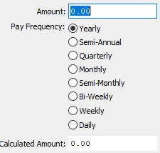

The user may enter the total dollar amount paid to the employee. The user may then select the pay frequency fort his particular employee. Valid choices are as follows:

|  |  |  |  |
| --- | --- | --- | --- |
| Yearly | Semi-Annual | Quarterly | Monthly |
| Semi-Monthly | Bi-Weekly | Weekly | Daily |

To choose the preferred pay frequency, please make sure the desired option choice bubble is toggled.

Once the user has chosen the pay frequency the total dollar amount will be divided by the payment period chosen to determine the hourly rate. For example, we could add $800 dollars in the amount field, click the weekly pay basis, press the OK and the rate of $20 per hour would transfer to the hourly rate field.

#### Factor Type (Choice)

The factor type field defines the multiplication factor for the pay rate. The options include a standard rate, additional rate and multiplied rate. The standard rate is equal to the hourly rate, the additional rate is a dollar amount added a standard rate and multiplied rate is the factor multiplied by the standard rate.

To choose the preferred factor type, please make sure the desired option choice bubble is toggled.

#### Calculated Rate

The net result of all the above choice calculations is the calculated rate which is used for costing the man hours labor times.

### Log In/Out

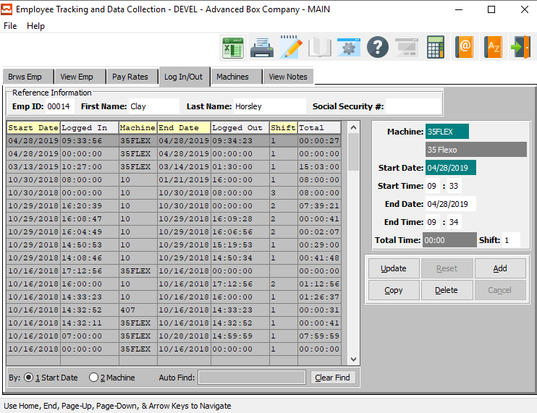

To add, change, delete, or view an employee's log in and log out history, the tab entitled “***Log In/Out***” must be selected after selecting an employee. The employees log in/log out browser will list the current machine transactions for an individual employee.

The browser shows the employee ID, first name, last name, and social security number as the reference information at the top of the browser. The detail section of the browser shows a list of machine transactions for the employee showing the transactions start date, log in time, machine code, ending date, time log out, shift and total hours for that machine transaction for that employee.

#### UPDATE

To change the currently selected log transaction, simply click the ***“Update***” button at the bottom of the screen.

#### ADD

Click the ***“Add”*** button at the bottom of the screen to add a new log transaction.

#### COPY

Click the ***“Copy”*** button to copy information from the currently selected log transaction.

#### DELETE

To delete the currently selected log transaction, simply press the ***"D"*** key. Alternatively, click the ***“Delete”*** button at the bottom of the screen.

### Add/Update Machine Log In/Out

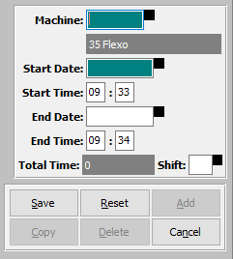

#### SAVE

Click the ***“Save”*** button to save all changes to the current log transaction.

#### RESET

Click the ***“Reset”*** button to reset all fields to their original state.

#### CANCEL

Click the ***“Cancel”*** button to cancel all changes to the log transaction without saving.

### Add/Update Machine Log In/Out Field Definitions

#### Machine

Enter the machine code that the employee was using for this transaction.

#### Start Date / End Date

Enter the starting and ending dates for this transaction.

#### Start Time / End Time

Enter the starting and ending times for this transaction.

#### Total Time

The total time will automatically calculate as soon as the user enters the starting and ending dates and times for this transaction. This field is not directly modifiable by the user. Rather, it is only adjustable by changing the aforementioned fields.

#### Shift

Enter the shift for this transaction.

### Machines

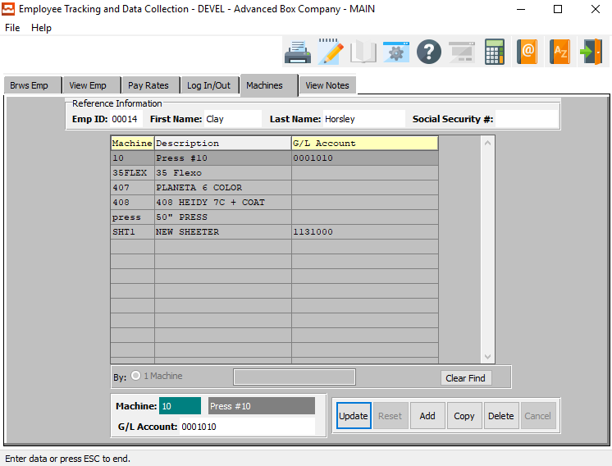

The employee machine folder allows definition of machine's which the employee will operate on the plant floor so that the machine buttons are available when posting production. To add, change, delete, or view an employee's machine list, the folder called MACHINE must be selected after selecting an employee.

The employee's Machine browser will list the current machine that an individual employee may operate during the day. The browser shows the employee ID, first name, last name, and social security number as the reference information at the top of the browser. The detail section of the browser shows a list of machines for the employee showing the machine care, machine description and general ledger expense account number for that employee.

#### UPDATE

To change the currently selected Machine, simply click the ***“Update***” button at the bottom of the screen.

#### ADD

Click the ***“Add”*** button at the bottom of the screen to add a new Machine.

#### COPY

Click the ***“Copy”*** button to copy information from the currently selected Machine.

#### DELETE

To delete the currently selected Machine, simply press the ***"D"*** key. Alternatively, click the ***“Delete”*** button at the bottom of the screen.

### Add/Update Machine

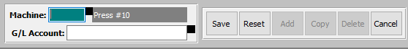

#### SAVE

Click the ***“Save”*** button to save all changes to the current XXX.

#### RESET

Click the ***“Reset”*** button to reset all fields to their original state.

#### CANCEL

Click the ***“Cancel”*** button to cancel all changes to the XXX without saving.

### Add/Update Machine Field Definitions

#### Machine

Enter the code for this machine. Alternatively, the user may press the ***“F1”*** key to choose a code from a list of valid Machine Codes.

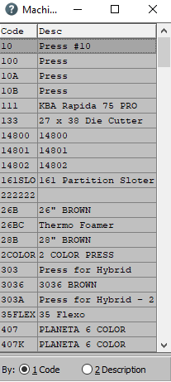

#### G/L Account

Enter the General Ledger Account number for this machine. Alternatively, the user may press the ***“F1”*** key to choose a number from a list of available general ledger account numbers.

### View Notes

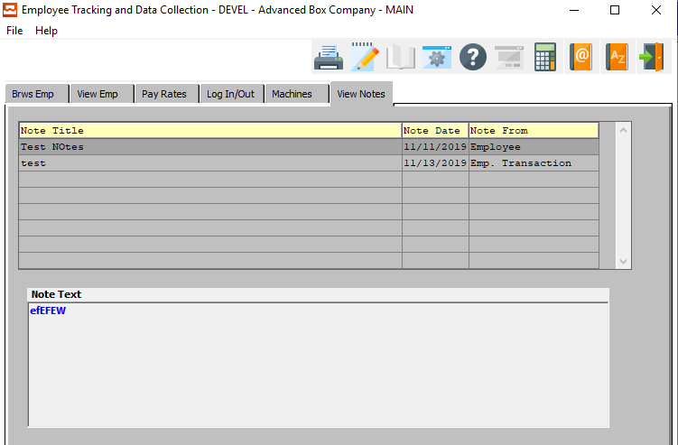

The *“Notes”* tab will show the user all of the available notes for the selected employee.

In order to view the detailed note text information for a specific note, the desired note must be selected within the list of all available notes.

In order to select a specific note within the list to view detailed note text information for, the user must ensure that it is highlighted within the list. In order to highlight the desired note, the user may click on their desired note.

## Employee Transaction Summary [TF2]

### Browse Employee

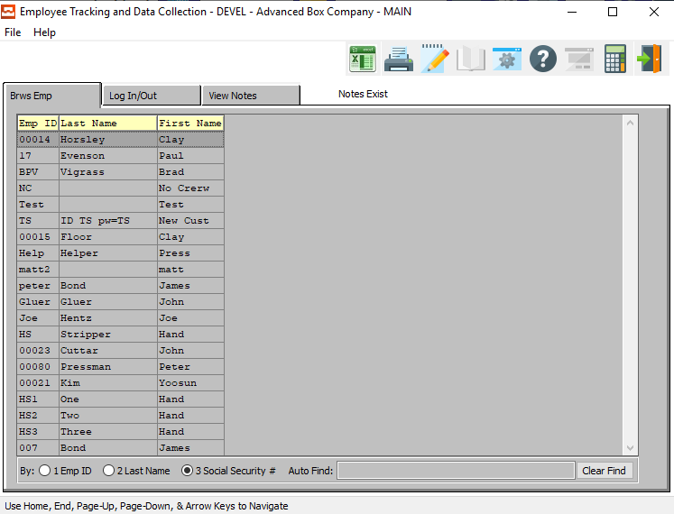

In order to view detailed information for a specific employee transaction history, the desired employee must be selected within the list of all available employees. The user may search for a specific employee, or narrow down the browse list, by using the search field located at the bottom of the page.

In order to select a specific employee within the list to view detailed information for, the user must ensure that it is highlighted within the list. In order to highlight the desired employee, the user may click on their desired employee.

#### Log In/Out

Once the user has highlighted their desired employee to view detailed transaction history for, they may click on the ***“Log In/Out”*** tab at the top of the screen. This tab allows the user to view detailed information, as well as update and add transactions.

#### View Notes

Once the user has highlighted their desired employee to view detailed information for, they may click on the ***“View Notes”*** tab at the top of the screen.

### Log In/Out

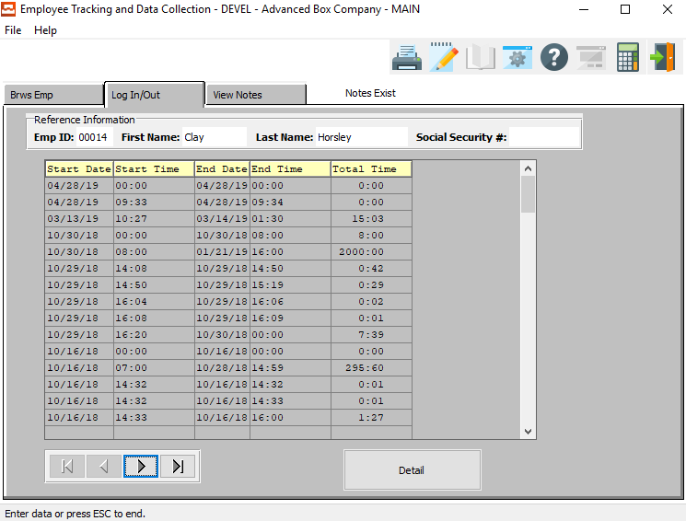

The *“Log In/Out”* screen will show the user all of the available transactions for the selected employee.

In order to view detailed information for a specific transaction, the desired transaction must be selected within the list of all available transactions.

In order to select a specific transaction within the list to view detailed information for, the user must ensure that it is highlighted within the list. In order to highlight the desired transaction, the user may click on their desired transaction line.

#### NEXT

Press ***"N"*** (Next) to find next employee transaction history to view or modify. Alternatively, press the ***“Right Arrow”*** on the screen.

#### PREVIOUS

Press ***"P"*** (Previous) to find previous employee transaction history to view or modify. Alternatively, press the ***“Left Arrow”*** on the screen.

#### Detail

Once the user has highlighted their desired transaction line to view detailed information for, they may click on the ***“Detail”*** button at the top of the screen. This popup screen allows the user to view detailed information, as well as update and add transactions.

### Detail

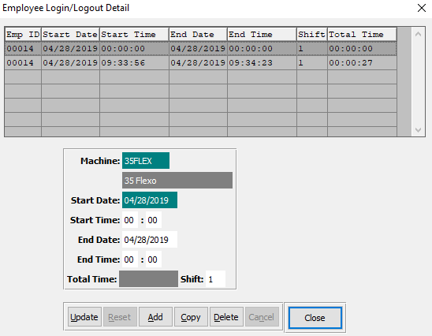

#### UPDATE

To change the currently selected transaction, simply click the ***“Update***” button at the bottom of the screen.

#### ADD

Click the ***“Add”*** button at the bottom of the screen to add a new transaction.

#### COPY

Click the ***“Copy”*** button to copy information from the currently selected transaction.

#### DELETE

To delete the currently selected transaction, simply press the ***"D"*** key. Alternatively, click the ***“Delete”*** button at the bottom of the screen.

#### CLOSE

Click the ***“Close”*** button to exit the transaction detail screen.

### Add/Update Login/Out Transaction

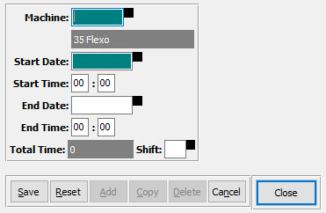

#### SAVE

Click the ***“Save”*** button to save all changes to the current transaction.

#### RESET

Click the ***“Reset”*** button to reset all fields to their original state.

#### CANCEL

Click the ***“Cancel”*** button to cancel all changes to the transaction without saving.

#### CLOSE

Click the ***“Close”*** button to exit the transaction detail screen.

### Add/Update Login/Out Transaction Field Definitions

#### Machine

Enter the machine code that the employee was using for this transaction.

#### Start Date / End Date

Enter the starting and ending dates for this transaction.

#### Start Time / End Time

Enter the starting and ending times for this transaction.

#### Total Time

The total time will automatically calculate as soon as the user enters the starting and ending dates and times for this transaction. This field is not directly modifiable by the user. Rather, it is only adjustable by changing the aforementioned fields.

#### Shift

Enter the shift for this transaction.

### View Notes

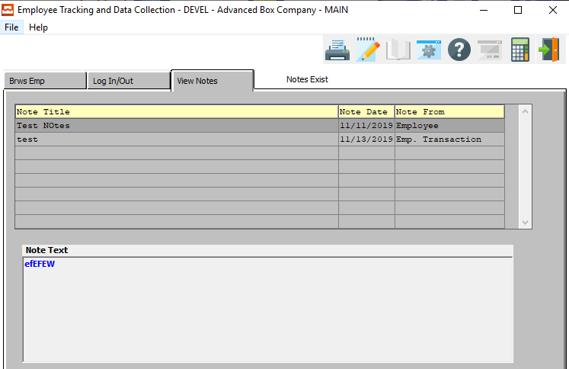

The *“Notes”* tab will show the user all of the available notes for the selected employee.

In order to view the detailed note text information for a specific note, the desired note must be selected within the list of all available notes.

In order to select a specific note within the list to view detailed note text information for, the user must ensure that it is highlighted within the list. In order to highlight the desired note, the user may click on their desired note.

## Machine Transactions [TF3]

### Machine Data Collection Auditing

This browser shows the labor charge code, starting date, log in time, date finished, log out time, shift, total hours, quantity produced and quantity of waste for each process. The operator may change the data of any transaction by double clicking any highlighted transaction. This will transfer the operator to the *View Transaction* screen, which will allow the operator to update the transaction.

This screen also provides the ability to add, copy, delete, or view additional transactions by using the ***“Update”***, ***“Add”***, ***“Copy”***, or ***“Delete”*** buttons, respectively. To add or change any information on the *View Transaction* screen, simply press the data field that requires modification. Once the data has been changed, the operator must press the ***“Save”*** button to record the corrections.

### Browse Transactions

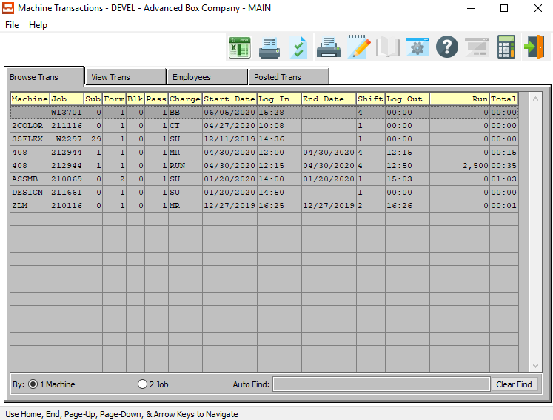

The Machine Transaction Browser shows a list of unposted machine transactions, which may be sorted by the machine code or the job number. Once a machine transaction is highlighted on the screen, the user may simply ***“Double-Click”*** with their mouse or press the ***“Enter”*** key to view or change the employee data.

The browser is very similar to the “***F5”*** function key which Advantzware users are familiar with using. To sort by the machine code or job number, simply check the appropriate field at the bottom of the browser and the list will be resorted in that order. To find a particular machine transaction, the *Auto Find* search box at the bottom of the browser provides an alpha numeric search capability by typing a few characters and pressing the ***“Enter”*** key.

The Machine Transaction browser shows the machine code, job number, form No., blank number, printing press pass number, machine charge code, starting date, log in time, the ending date, shift number, the log out time, run the quantity produced and total hours for the machine transaction.

The other tabs listed on the machine transaction browser screen provide the ability to add, change, delete and copy the machine transactions information including the starting date, ending date, shift number, time started, time ended, machine charge code, run the quantity produced and the quantity wasted.

#### Transactions Competed After Midnight

If a Job Run is started late on one day, and finished on the next day, the Advantzware Touch Screen software automatically creates two lines. The first of these transactions lines will end one minute before midnight, and as the system uses military time, will be set to 23:59.

The software code then adds a second line, starting the transaction at midnight (0:00), and ending the time at the true entered transaction end time.

In summary, the dates are automatically created so that data collection reports can be printed by their proper date ranges.

### View Transaction

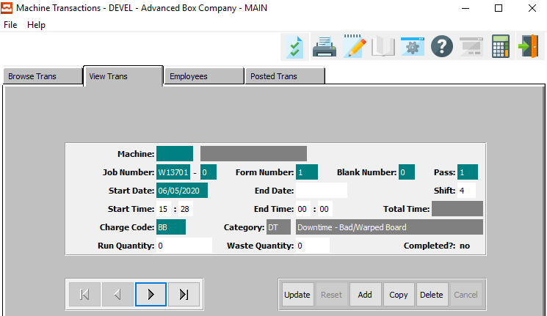

To add, change, delete, or view an unposted machine transaction, the tab entitled ***“View Trans”*** must be selected. The only information that may be changed for a machine transaction is the ending date, shift number, starting time, ending time, charge code, run quantity produced and quantity wasted. If the machine code or job number must be changed, then the entire transaction must be deleted and a new transaction created

#### UPDATE

To change the currently selected transaction, simply click the ***“Update***” button at the bottom of the screen.

#### ADD

Click the ***“Add”*** button at the bottom of the screen to add a new transaction.

#### COPY

Click the ***“Copy”*** button to copy information from the currently selected transaction.

#### DELETE

To delete the currently selected transaction, simply press the ***"D"*** key. Alternatively, click the ***“Delete”*** button at the bottom of the screen.

#### NEXT

Press ***"N"*** (Next) to find next transaction to view or modify. Alternatively, press the ***“Right Arrow”*** on the screen.

#### PREVIOUS

Press ***"P"*** (Previous) to find previous transaction to view or modify. Alternatively, press the ***“Left Arrow”*** on the screen.

### Add/Update Transaction

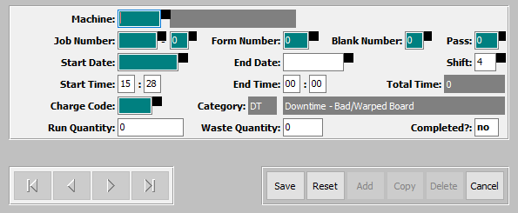

#### SAVE

Click the ***“Save”*** button to save all changes to the current transaction.

#### RESET

Click the ***“Reset”*** button to reset all fields to their original state.

#### CANCEL

Click the ***“Cancel”*** button to cancel all changes to the transaction without saving.

### Add/Update Transaction Field Definitions

#### Machine

Enter the machine code for this Machine Transaction. Alternatively, the user may press the ***“F1”*** key to choose a code from a list of valid Machine Codes.

Once the user has entered or selected a valid machine code, the machine name field will automatically populate.

#### Job Number

Enter the job number for this Machine Transaction. Alternatively, the user may press the ***“F1”*** key to choose a number from a list of valid job numbers.

#### Job Number: 00

Enter the subsequent job number for this Machine Transaction, if applicable.

#### Form Number

Enter the number for the current form for this Machine Transaction.

#### Blank Number

Enter the number for the current blank for this Machine Transaction.

#### Pass Number

Enter the number for the current pass for this Machine Transaction.

#### Start Date / End Date

Enter the starting and ending dates for this Machine Transaction.

#### Shift

Enter the shift number for this Machine Transaction.

#### Start Time / End Time

Enter the starting and ending times for this Machine Transaction.

#### Charge Code

Enter the charge code for this Machine Transaction. Alternatively, the user may press the ***“F1”*** key to choose a code from a list of valid Job Codes.

#### Run Quantity

Enter the run quantity for this Machine Transaction.

#### Waste Quantity

Enter the waste quantity for this Machine Transaction.

#### Completed?

The user may toggle this Job as complete or incomplete by entering a ‘*yes*’ or a ‘*no*’ in this field.

### Employee Transactions by Machine

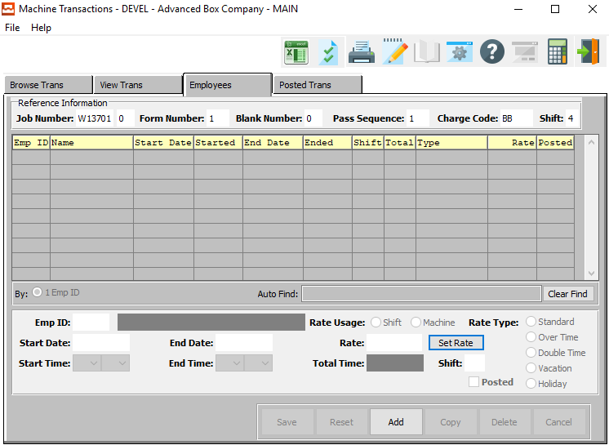

This browser shows employee transactions for a particular machine transaction. All employees that are logged into that machine when the job data collection is added will automatically output to the employee transaction file for each machine transaction.

To add, change, delete, or view an non-posted machine transaction for individual employees, the tab entitled ***“Employees”*** must be selected, after or selecting the appropriate machine transaction. The only information that may be changed for a machine transaction is the ending date, shift number, starting time, ending time and the employee's hourly rate.

### Add Employee

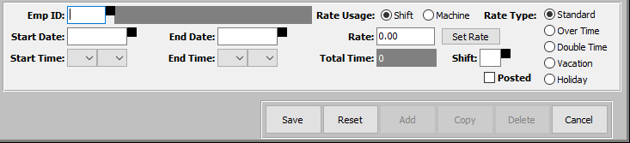

#### SAVE

Click the ***“Save”*** button to save all changes to the current transaction.

#### RESET

Click the ***“Reset”*** button to reset all fields to their original state.

#### CANCEL

Click the ***“Cancel”*** button to cancel all changes to the transaction without saving.

### Add Employee Field Definitions

#### Employee ID

Enter the employee’s ID number into this field. Alternatively, the user may press the ***“F1”*** key to choose a number from a list of available employees.

#### Start Date / End Date

Enter the starting and ending dates for this transaction.

#### Start Time / End Time

Enter the starting and ending times for this transaction.

#### Rate Usage (Choice)

This determines if the pay rate is for a particular machine or the pay rate is for the entire shift. If the employee has only one hourly rate for all machines that he operates, the rate usage should be set to ***shift***. If the employee is paid different hourly rates depending on the machine, the rate usage should be set to ***machine***.

To choose the preferred Rate Usage of Shift vs. Machine, please make sure the desired option choice bubble is toggled.

#### Rate

The hourly rate field is the dollar amount paid to the employee for the selected rate type.

#### SET RATE

The ***“Set Rate”*** button in conjunction with the rate price may be utilized to calculate the hourly rate for the employee.



The user may enter the total dollar amount paid to the employee. The user may then select the pay frequency fort his particular employee. Valid choices are as follows:

|  |  |  |  |
| --- | --- | --- | --- |
| Yearly | Semi-Annual | Quarterly | Monthly |
| Semi-Monthly | Bi-Weekly | Weekly | Daily |

To choose the preferred pay frequency, please make sure the desired option choice bubble is toggled.

Once the user has chosen the pay frequency the total dollar amount will be divided by the payment period chosen to determine the hourly rate. For example, we could add $800 dollars in the amount field, click the weekly pay basis, press the OK and the rate of $20 per hour would transfer to the hourly rate field.

#### Total Time

The total time will automatically calculate as soon as the user enters the starting and ending dates and times for this transaction. This field is not directly modifiable by the user. Rather, it is only adjustable by changing the aforementioned fields.

#### Shift

The shift field must be a valid shift defined in the shift file, therefore the “***F1”*** key may be used to display the valid shifts.

#### Posted – Toggle Box

To mark this as a posted transaction, make sure that the Posted toggle box is checked.

#### Rate Type (Choice)

The rate type field is used to differentiate different hourly rates for the same employee.

Available options are as follows:

|  |  |  |  |  |
| --- | --- | --- | --- | --- |
| Standard (Base) | Over Time | Double Time | Vacation | Holiday |

To choose the preferred rate type, please make sure the desired option choice bubble is toggled.

### Posted Transactions

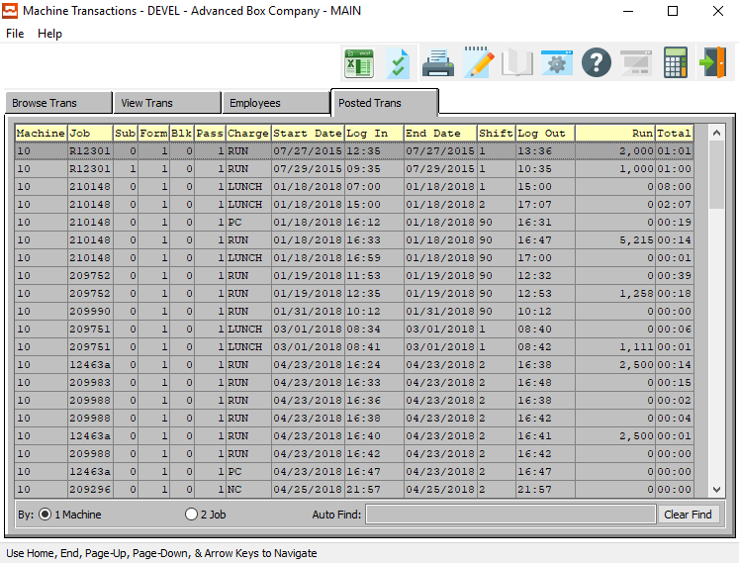

The Machine Transaction Browser shows a list of posted machine transactions, which may be sorted by the machine code or the job number, but cannot be changed. The browser is very similar to the “***F5”*** function key which Advantzware users are familiar with using.

To sort by the machine code or job number, simply check the appropriate field at the bottom of the browser and the list will be resorted in that order. To find a particular machine transaction, the *Auto Find* search box at the bottom of the browser provides an alpha numeric search capability by typing a few characters and pressing the ***“Enter”*** key.

The posted Machine Transaction browser shows the machine code, job number, form number, blank number, printing press pass number, machine charge code, starting date, log in time, the ending date, shift number, the log out time, the run quantity produced and total hours for the machine transaction.

## Employee Transactions [TF4]

### Browse Employees

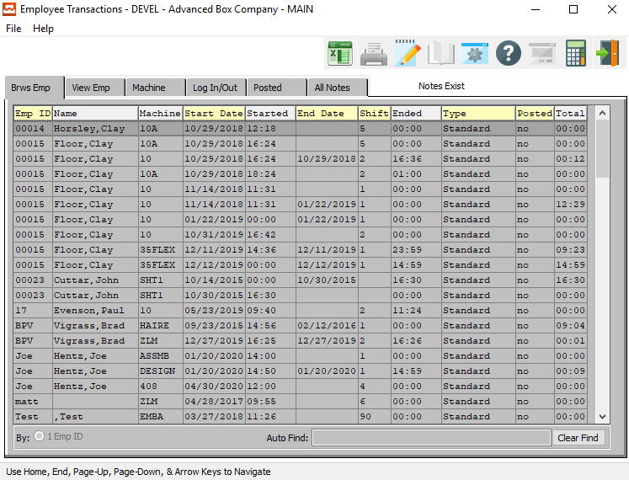

The Employee Transaction Browser shows a list of unposted employee transactions, which are sorted by the employee code. Once an employee transaction is highlighted on the screen, the user may ***“Double-Click”*** with their mouse or press the ***“Enter”*** key to view or change the employee data. The browser is very similar to the “***F5”*** function key which Advantzware users are familiar with using.

To sort by the employee code, simply check the appropriate field at the bottom of the browser and the list will be resorted in that order. To find a particular employee transaction, the *Auto Find* search box at the bottom of the browser provides an alpha numeric search capability by typing a few characters and pressing the ***“Enter”*** key.

The employee Transaction browser shows the employee code, employee name, machine code, starting date, time started, the ending date, the log out time, shift number, labor rate type, the run quantity produced, the total hours for the employee transaction and the posted for unposted flag.

### View Employee

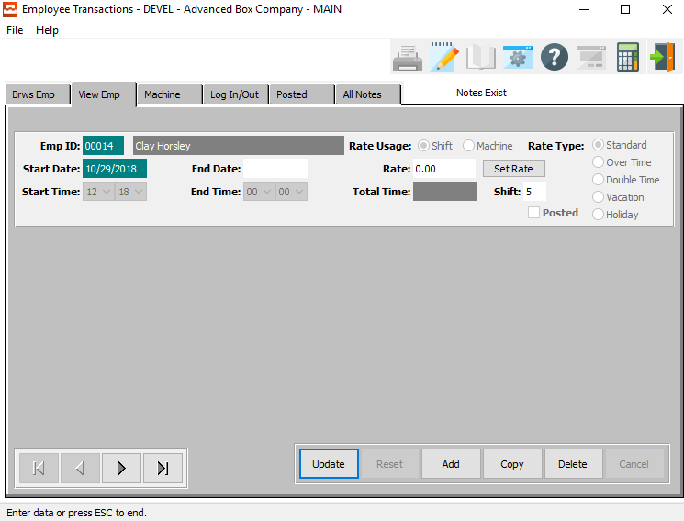

To add, change, delete, or view an unposted employee transaction, the tab entitled *View Employee* must be selected. The only information that may be changed for an employee transaction is the ending date, shift number, starting time, ending time and the employee's labor rate.

#### UPDATE

To change the currently selected employee information, simply click the ***“Update***” button at the bottom of the screen.

#### ADD

Click the ***“Add”*** button at the bottom of the screen to add a new employee information.

#### DELETE

To delete the currently selected employee information, simply press the ***"D"*** key. Alternatively, click the ***“Delete”*** button at the bottom of the screen.

#### NEXT

Press ***"N"*** (Next) to find next employee information to view or modify. Alternatively, press the ***“Right Arrow”*** on the screen.

#### PREVIOUS

Press ***"P"*** (Previous) to find previous employee information to view or modify. Alternatively, press the ***“Left Arrow”*** on the screen.

### Add/Update Employee Transaction

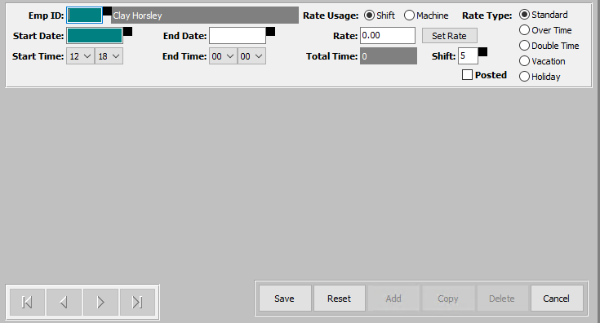

#### SAVE

Click the ***“Save”*** button to save all changes to the current transaction.

#### RESET

Click the ***“Reset”*** button to reset all fields to their original state.

#### CANCEL

Click the ***“Cancel”*** button to cancel all changes to the transaction without saving.

### Add/Update Employee Transaction Field Definitions

#### Employee ID

Enter the employee’s ID number into this field. Alternatively, the user may press the ***“F1”*** key to choose a number from a list of available employees.

#### Start Date / End Date

Enter the starting and ending dates for this transaction.

#### Start Time / End Time

Enter the starting and ending times for this transaction.

#### Rate Usage (Choice)

This determines if the pay rate is for a particular machine or the pay rate is for the entire shift. If the employee has only one hourly rate for all machines that he operates, the rate usage should be set to ***shift***. If the employee is paid different hourly rates depending on the machine, the rate usage should be set to ***machine***.

To choose the preferred Rate Usage of Shift vs. Machine, please make sure the desired option choice bubble is toggled.

#### Rate

The hourly rate field is the dollar amount paid to the employee for the selected rate type.

#### SET RATE

The ***“Set Rate”*** button in conjunction with the rate price may be utilized to calculate the hourly rate for the employee.



The user may enter the total dollar amount paid to the employee. The user may then select the pay frequency fort his particular employee. Valid choices are as follows:

|  |  |  |  |
| --- | --- | --- | --- |
| Yearly | Semi-Annual | Quarterly | Monthly |
| Semi-Monthly | Bi-Weekly | Weekly | Daily |

To choose the preferred pay frequency, please make sure the desired option choice bubble is toggled.

Once the user has chosen the pay frequency the total dollar amount will be divided by the payment period chosen to determine the hourly rate. For example, we could add $800 dollars in the amount field, click the weekly pay basis, press the OK and the rate of $20 per hour would transfer to the hourly rate field.

#### Total Time

The total time will automatically calculate as soon as the user enters the starting and ending dates and times for this transaction. This field is not directly modifiable by the user. Rather, it is only adjustable by changing the aforementioned fields.

#### Shift

The shift field must be a valid shift defined in the shift file, therefore the “***F1”*** key may be used to display the valid shifts.

#### Posted – Toggle Box

To mark this as a posted transaction, make sure that the Posted toggle box is checked.

#### Rate Type (Choice)

The rate type field is used to differentiate different hourly rates for the same employee.

Available options are as follows:

|  |  |  |  |  |
| --- | --- | --- | --- | --- |
| Standard (Base) | Over Time | Double Time | Vacation | Holiday |

To choose the preferred rate type, please make sure the desired option choice bubble is toggled.

### Machine

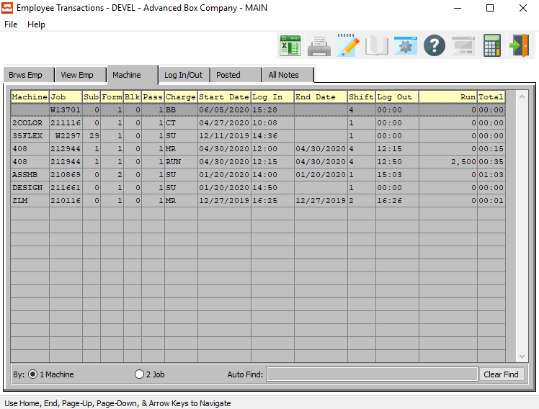

To view an unposted machine transaction for individual employee, the tab entitled *Machine* must be selected, after selecting the appropriate employee transaction from employee browser. No information may be changed for an employee's machine transaction. The browser is very similar to the “***F5”*** function key which Advantzware users are familiar with using.

To sort by the machine code or job number, simply check the appropriate field at the bottom of the browser and the list will be resorted in that order. To find a particular machine transaction, the *Auto Find* search box at the bottom of the browser provides an alpha numeric search capability by typing a few characters and pressing the ***“Enter”*** key.

The Machine Transaction browser shows an individual employees machine code, job number, form number, blank number, printing press pass number, machine charge code, starting date, log in time, the ending date, shift number, the log out time, run the quantity produced and total hours for the machine transaction. To change the transaction, the tab entitled *Machine Transaction* under file maintenance should be selected.

### Log In/Out

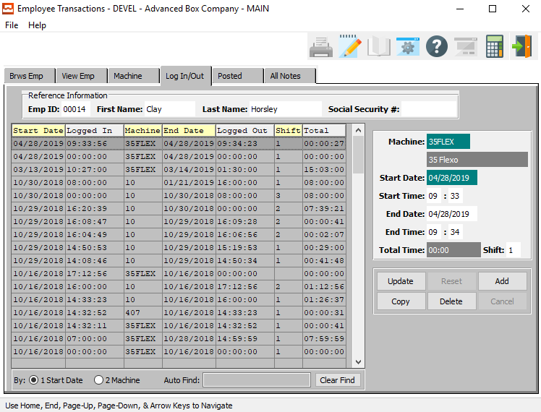

The *“Log In/Out”* screen will show the user all of the available transactions for the selected employee.

In order to view detailed information for a specific transaction, the desired transaction must be selected within the list of all available transactions.

In order to select a specific transaction within the list to view detailed information for, the user must ensure that it is highlighted within the list. In order to highlight the desired transaction, the user may click on their desired transaction line.

#### UPDATE

To change the currently selected transaction, simply click the ***“Update***” button at the bottom of the screen.

#### ADD

Click the ***“Add”*** button at the bottom of the screen to add a new transaction.

#### COPY

Click the ***“Copy”*** button to copy information from the currently selected transaction.

#### DELETE

To delete the currently selected transaction, simply press the ***"D"*** key. Alternatively, click the ***“Delete”*** button at the bottom of the screen.

### Add/Update Log In/Out

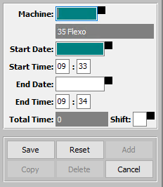

#### SAVE

Click the ***“Save”*** button to save all changes to the current transaction.

#### RESET

Click the ***“Reset”*** button to reset all fields to their original state.

#### CANCEL

Click the ***“Cancel”*** button to cancel all changes to the transaction without saving.

### Add/Update Log In/Out Field Definitions

#### Machine

Enter the machine code that the employee was using for this transaction.

#### Start Date / End Date

Enter the starting and ending dates for this transaction.

#### Start Time / End Time

Enter the starting and ending times for this transaction.

#### Total Time

The total time will automatically calculate as soon as the user enters the starting and ending dates and times for this transaction. This field is not directly modifiable by the user. Rather, it is only adjustable by changing the aforementioned fields.

#### Shift

Enter the shift for this transaction.

### Posted Transactions

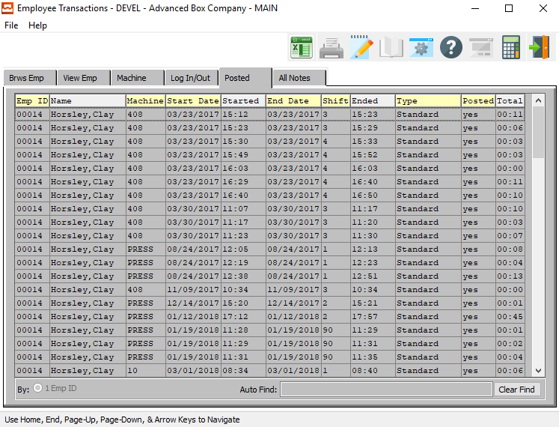

The employee Transaction Browser shows a list of posted employee transactions for each machine, which are sorted by the employee code, but cannot be changed. The browser is very similar to the “***F5”*** function key which Advantzware users are familiar with using.

To find a particular employee transaction, the *Auto Find* search box at the bottom of the browser provides an alpha numeric search capability by typing a few characters and pressing the ***“Enter”*** key.

The posted employee Transaction browser shows the employee code, employee name, machine number, starting date, log in time, the ending date, shift number, the log out time, the labor hourly rate type, the total hours for the employee transaction and the posted for unposted flag.

### All Notes

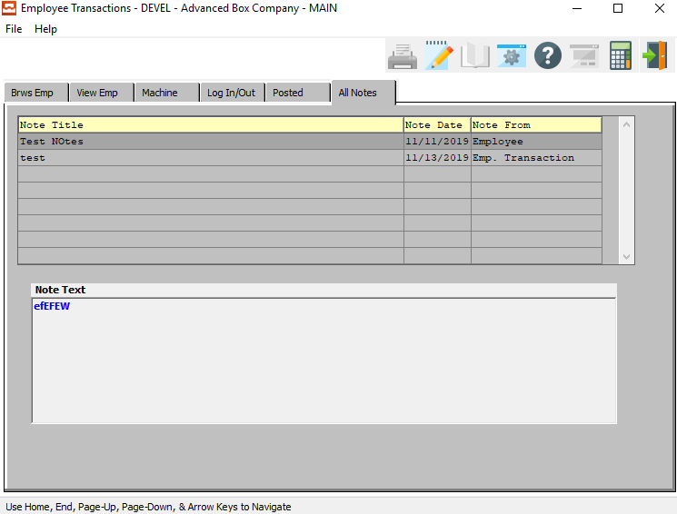

The *“Notes”* tab will show the user all of the available notes for the selected employee.

In order to view the detailed note text information for a specific note, the desired note must be selected within the list of all available notes.

In order to select a specific note within the list to view detailed note text information for, the user must ensure that it is highlighted within the list. In order to highlight the desired note, the user may click on their desired note.

## Completed Machine Jobs [TF5]

### Browse Jobs

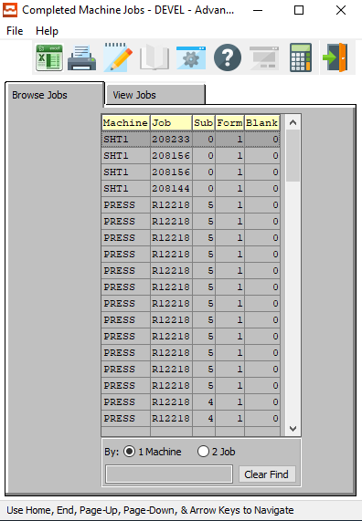

The completed machine by job browser shows a list of machine transactions for each job number, which are sorted by the machine code, but cannot be changed. The browser is very similar to the “***F5”*** function key which Advantzware users are familiar with using.

To find a particular employee transaction, the *Auto Find* search box at the bottom of the browser provides an alpha numeric search capability by typing a few characters and pressing the ***“Enter”*** key. The completed machine by job browser shows the machine number and to number.

### View Jobs

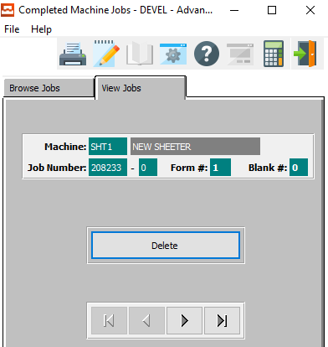

#### DELETE

To delete the currently selected machine job, simply press the ***"D"*** key. Alternatively, click the ***“Delete”*** button at the bottom of the screen.

#### NEXT

Press ***"N"*** (Next) to find next machine job to view or modify. Alternatively, press the ***“Right Arrow”*** on the screen.

#### PREVIOUS

Press ***"P"*** (Previous) to find previous machine job to view or modify. Alternatively, press the ***“Left Arrow”*** on the screen.

## Job Sequence [TF6]

### Browse Sequence

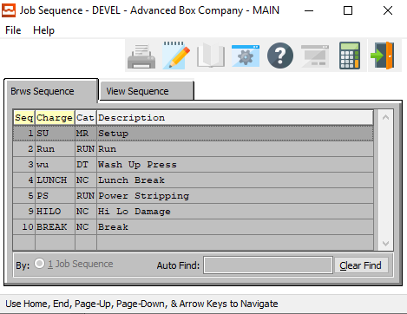

The job sequence browser shows a list of the normal manufacturing steps that a machine will process for a job. The charge codes list serves as a default when assigning machine charge codes. This list of manufacturing steps speeds the plant floor data collection because the operator is no longer required to enter the machine charge codes.

In addition, the program remembers the last operation performed on a machine and will automatically transfer the next charge code for the machine operation. Once a machine charge code is highlighted on the screen, simply double click with your mouse or press the ***“Enter”*** key to view or change the machine charge code data.

The browser is very similar to the “***F5”*** function key which Advantzware users are familiar with using. To find a particular job sequence or machine charge code, the *Auto Find* search box block at the bottom of the browser provides an alpha numeric search capability by typing a few characters and pressing the ***“Enter”*** key. The job sequence browser shows the sequence number, machine charge code, job costing category for the charge code and the description for the labor charge.

### View Sequence

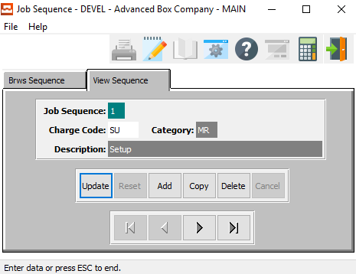

To add, change, delete, or view a machine charge code sequence, the folder called VIEW SEQUENCE must be selected. The only information that may be changed for a machine charge code sequence is the charge code, category and the description. If the employee code or starting date must be changed, then the entire transaction must be deleted, and a new transaction created.

#### UPDATE

To change the currently selected job sequence, simply click the ***“Update***” button at the bottom of the screen.

#### ADD

Click the ***“Add”*** button at the bottom of the screen to add a new job sequence.

#### COPY

Click the ***“Copy”*** button to copy information from the currently selected job sequence.

#### DELETE

To delete the currently selected job sequence, simply press the ***"D"*** key. Alternatively, click the ***“Delete”*** button at the bottom of the screen.

#### NEXT

Press ***"N"*** (Next) to find next job sequence to view or modify. Alternatively, press the ***“Right Arrow”*** on the screen.

#### PREVIOUS

Press ***"P"*** (Previous) to find previous job sequence to view or modify. Alternatively, press the ***“Left Arrow”*** on the screen.

### Add/Update Sequence

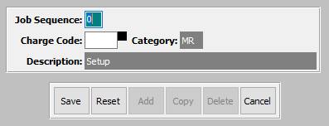

#### SAVE

Click the ***“Save”*** button to save all changes to the current job sequence.

#### RESET

Click the ***“Reset”*** button to reset all fields to their original state.

#### CANCEL

Click the ***“Cancel”*** button to cancel all changes to the job sequence without saving.

### Add/Update Sequence Field Definitions

#### Job Sequence

Enter the number for this particular job sequence.

#### Charge Code

Enter a valid charge code for this job sequence. Alternatively, the user may press the ***“F1”*** key to choose a code from a list of valid Charge Codes.

## Shifts [TF7]

### Browse Shifts

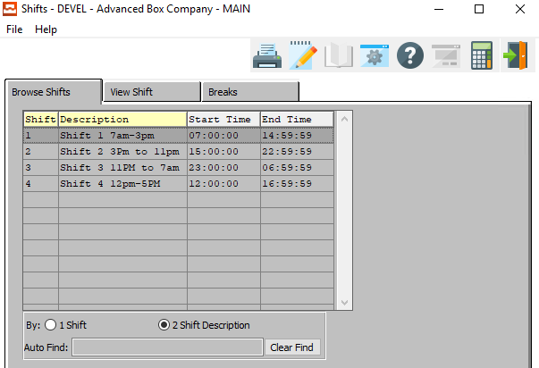

The job shifts browser shows a list of the production shifts for the entire manufacturing plant. This file provides the ability to have shifts with different start and stop times or each machine or departmental center.

For example, shifts could be defined for the glowing department starting at 5 in the morning, whereas shifts for the printing department could begin at 7 in the morning.

This list of manufacturing shifts can be used when defining shares for a machine in the machine file. During plant floor data collection, the system will automatically calculates the shift number based on the machine transaction times which are entered by the operator.

To select a shift, highlight the shift on the screen, the user may ***“Double-Click”*** with their mouse or press the ***“Enter”*** key to view or change the shift code data. The browser is very similar to the “***F5”*** function key which Advantzware users are familiar with using.

To find a particular shift, the *Auto Find* search box at the bottom of the browser provides an alpha numeric search capability by typing a few characters and pressing the ***“Enter”*** key. The shifts browser shows the shift number, description of the shift, starting time of the shift and the ending time of the shift.

### View Shift

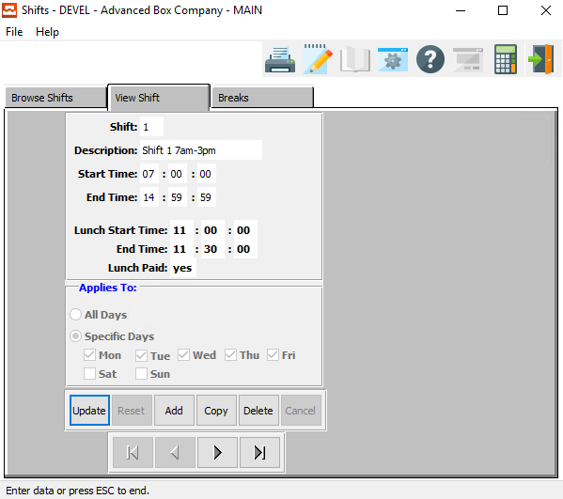

To add, change, delete, or view a shift for the plant, the tab entitled *View Shift* must be selected. The only information that may be changed for a shift is the shift description, starting time of the shift and ending time of the shift.

#### UPDATE

To change the currently selected shift, simply click the ***“Update***” button at the bottom of the screen.

#### ADD

Click the ***“Add”*** button at the bottom of the screen to add a new shift.

#### COPY

Click the ***“Copy”*** button to copy information from the currently selected shift.

#### DELETE

To delete the currently selected shift, simply press the ***"D"*** key. Alternatively, click the ***“Delete”*** button at the bottom of the screen.

#### NEXT

Press ***"N"*** (Next) to find next shift to view or modify. Alternatively, press the ***“Right Arrow”*** on the screen.

#### PREVIOUS

Press ***"P"*** (Previous) to find previous shift to view or modify. Alternatively, press the ***“Left Arrow”*** on the screen.

### Add/Update Shift

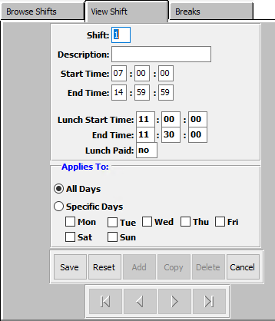

#### SAVE

Click the ***“Save”*** button to save all changes to the current shift.

#### RESET

Click the ***“Reset”*** button to reset all fields to their original state.

#### CANCEL

Click the ***“Cancel”*** button to cancel all changes to the shift without saving.

### Add/Update Shift Field Definitions

#### Shift

Enter a number for this shift for future system use.

#### Description

Enter a short description of this shift.

#### Start Time / End Time

Enter the starting and ending times for this shift.

#### Lunch Start Time / End Time

Enter the starting and ending time for the lunch period of this shift.

#### Lunch Paid

The user has two choices for this field. If they wish to allow the lunch for this shift to be a paid period of time, they should enter ‘*yes*’ here. If the lunch for this shift is unpaid, they should enter a ‘*no’* in this field.

#### Applies To (Choice)

To choose the preferred application of this shift of All Days vs. Specific, please make sure the desired option choice bubble is toggled.

If the user has chosen *Specific Days*, they must choose which days they wish to apply these shift rules to. To choose a day, make sure that the toggle box next to it is checked.

### Breaks

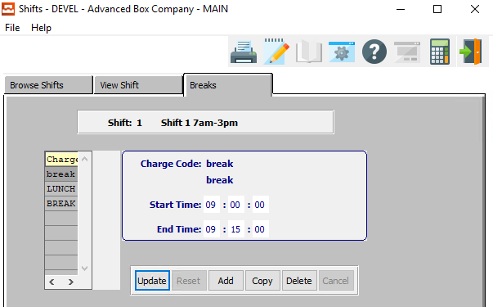

#### UPDATE

To change the currently selected break shift, simply click the ***“Update***” button at the bottom of the screen.

#### ADD

Click the ***“Add”*** button at the bottom of the screen to add a new break shift.

#### COPY

Click the ***“Copy”*** button to copy information from the currently selected break shift.

#### DELETE

To delete the currently selected break shift, simply press the ***"D"*** key. Alternatively, click the ***“Delete”*** button at the bottom of the screen.

### Add/Update Break

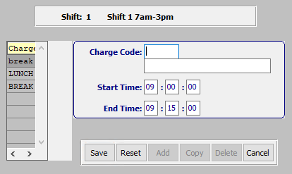

#### SAVE

Click the ***“Save”*** button to save all changes to the current break shift.

#### RESET

Click the ***“Reset”*** button to reset all fields to their original state.

#### CANCEL

Click the ***“Cancel”*** button to cancel all changes to the break shift without saving.

### Add/Update Break Field Definitions

#### Charge Code

Enter the charge code for this break period. Alternatively, press the ***“F1”*** key to choose a code from a list of valid charge codes.

#### Start Time / End Time

Enter the starting and ending time for this break period.

## Machine Assigned Charge Codes [TF8]

### Browse Machine

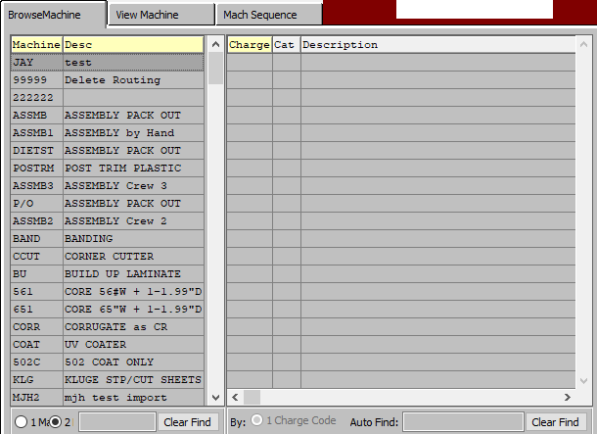

The machine assigned charge codes browser shows a list of machines and labor charge codes. This list of manufacturing charge codes must be defined for each machine. Examples include make ready, run, lunch, downtime, no work, bad board, etc.

The machine charge codes are presented as buttons during the plant floor data collection process. This speeds floor reporting because the operator is no longer required to enter the machine charge codes. In addition, the program remembers the last operation performed on a machine and will automatically transfer the next charge code for the machine operation. Once machine charge code is highlighted on the screen, the user may ***“Double-Click”*** with their mouse or press the ***“Enter”*** key to view or change the machine charge code data.

The browser is very similar to the “***F5”*** function key which Advantzware users are familiar with using. To find a particular job sequence or machine charge code, the *Auto Find* search box at the bottom of the browser provides an alpha numeric search capability by typing a few characters and pressing the ***“Enter”*** key. The machine assigned charge codes browser shows the machine number, machine description, machine charge code, job costing category for the charge code and the description for the labor charge code.

### View Machine

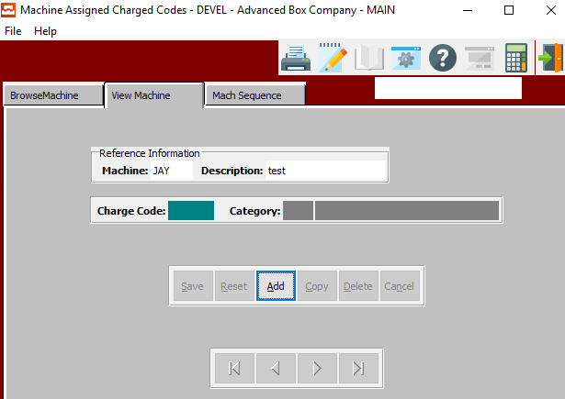

To add, change, delete, or view a machine charge code, the tab entitled *View Machine* must be selected. The only information that may be changed for a machine is the charge code and the description.

#### ADD

Click the ***“Add”*** button at the bottom of the screen to add a new machine.

### Add Machine

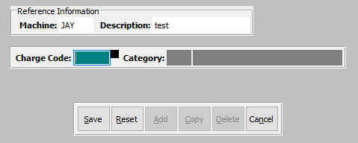

#### SAVE

Click the ***“Save”*** button to save all changes to the current machine.

#### RESET

Click the ***“Reset”*** button to reset all fields to their original state.

#### CANCEL

Click the ***“Cancel”*** button to cancel all changes to the machine without saving.

### Add Machine Field Definitions

#### Charge Code

Enter the charge code for this break period. Alternatively, press the ***“F1”*** key to choose a code from a list of valid charge codes.

### Machine Sequence

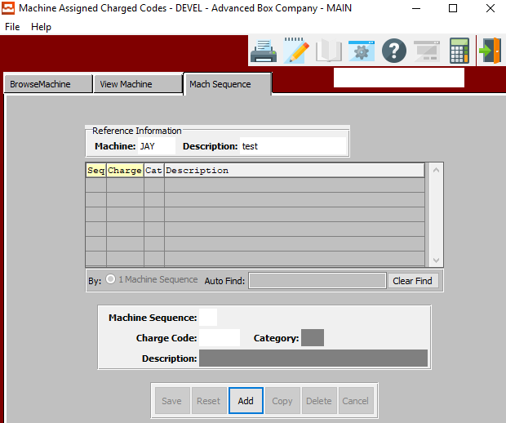

To add, change, delete, or view a machine charge code sequence, the tab entitled *Machine Sequence* must be selected. The only information that may be changed for a machine is the charge code sequence number.

#### ADD

Click the ***“Add”*** button at the bottom of the screen to add a new machine sequence.

### Add Machine Sequence

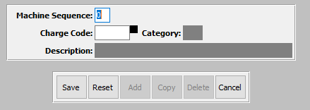

#### SAVE

Click the ***“Save”*** button to save all changes to the current machine sequence.

#### RESET

Click the ***“Reset”*** button to reset all fields to their original state.

#### CANCEL

Click the ***“Cancel”*** button to cancel all changes to the machine sequence without saving.

### Add Machine Sequence Field Definitions

#### Machine Sequence

Enter a number for this machine sequence.

#### Heading4

#### Charge Code

Enter the charge code for this break period. Alternatively, press the ***“F1”*** key to choose a code from a list of valid charge codes.

## Machine Assigned Shifts [TF9]

### Browse Machine

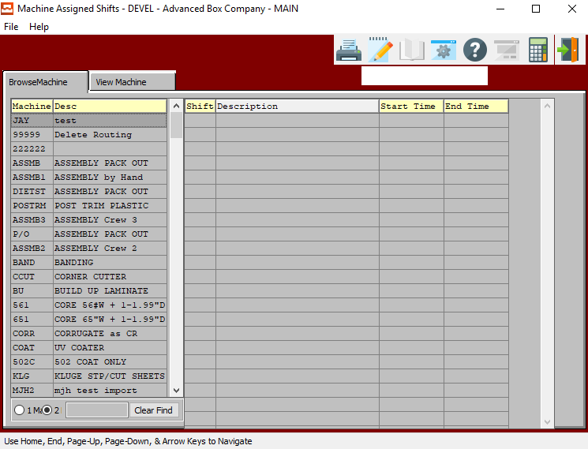

The machine assigned shifts browser shows a list of the production shifts for a particular machine. This file is not necessary if all the machines in the plant run on the same shift schedule. Under that circumstance the shift file would be utilized to determine the shift number during plant data collection.

This file provides the ability to have shifts with different start and stop times or each machine or departmental center. For example, shifts could be defined for the glowing department starting at 5 in the morning, whereas shifts for the printing department could begin at 7 in the morning.

This list of manufacturing shifts can be used when defining shares for a machine in the machine file. During plant floor data collection, the system will automatically calculate the shift number based on the machine transaction times which are entered by the operator.

To select a shift, highlight the shift on the screen, the user may ***“Double-Click”*** with their mouse or press the ***“Enter”*** key to view or change the shift code data. The browser is very similar to the F5 function key which Advantzware users are familiar with using.

To find a particular shift, the *Auto Find* search box at the bottom of the browser provides an alpha numeric search capability by typing a few characters and pressing the ***“Enter”*** key. The shifts browser shows the shift number, description of the shift, starting time of the shift and the ending time of the shift.

### View Machine

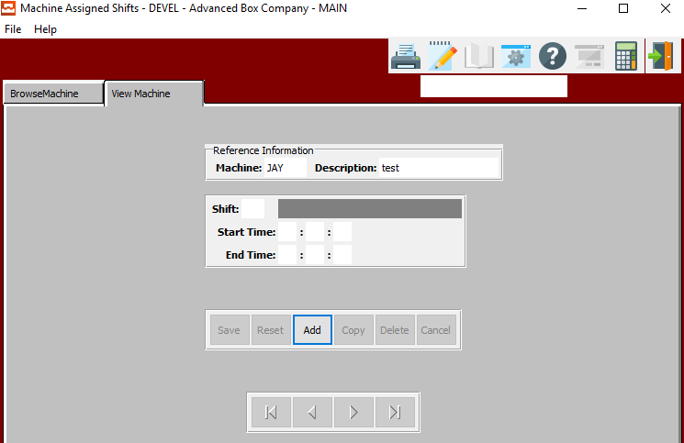

To add, change, delete, or view a shift for the plant, the folder called VIEW MACHINE must be selected. The only information that may be changed for a machine shift is the shift's starting time of the shift and ending time of the shift.

#### ADD

Click the ***“Add”*** button at the bottom of the screen to add a new machine shift.

### Add Machine

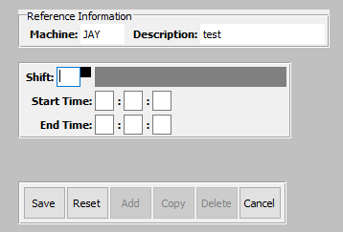

#### SAVE

Click the ***“Save”*** button to save all changes to the current machine shift.

#### RESET

Click the ***“Reset”*** button to reset all fields to their original state.

#### CANCEL

Click the ***“Cancel”*** button to cancel all changes to the machine shift without saving.

### Add Machine Field Definitions

#### Shift

The shift field must be a valid shift defined in the shift file, therefore the “***F1”*** key may be used to display the valid shifts.

#### Start Time / End Time

Enter the starting and ending times for this transaction.

## Employee Default Rates [TF)]

### Browse Rates

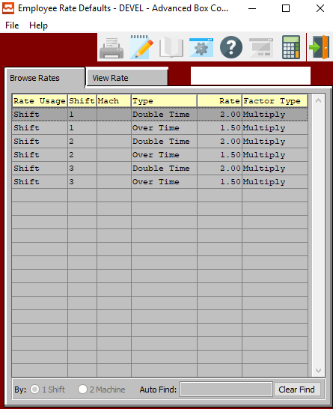

The hourly rates file serves to establish standard hourly labor rates for the entire company; therefore, this file should be billed before adding new employees. Building this file will help to speed the data entry process of adding employees. Therefore, if numerous employees have the same labor rates the company labor rates defined in this file will serve as default of adding new employees.

### View Rate

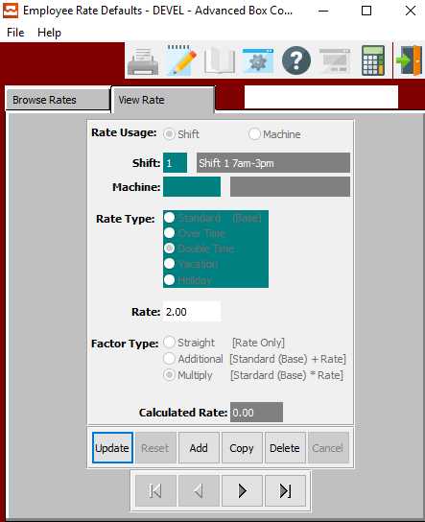

To add, change, delete, or view an employee’s standard hourly or salary pay rates, the tab entitled *Vie Rates* must be selected after selecting an hourly rate. The pay rate browser will list the existing pay rates showing the rate usage (i.e. by machine or shift), shift number, machine code, rate type, hourly rate and factor type description.

#### UPDATE

To change the currently selected rate, simply click the ***“Update***” button at the bottom of the screen.

#### ADD

Click the ***“Add”*** button at the bottom of the screen to add a new rate.

#### COPY

Click the ***“Copy”*** button to copy information from the currently selected rate.

#### DELETE

To delete the currently selected rate, simply press the ***"D"*** key. Alternatively, click the ***“Delete”*** button at the bottom of the screen.

### Add/Update Rate

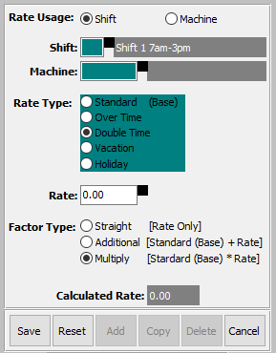

#### SAVE

Click the ***“Save”*** button to save all changes to the current rate.

#### RESET

Click the ***“Reset”*** button to reset all fields to their original state.

#### CANCEL

Click the ***“Cancel”*** button to cancel all changes to the rate without saving.

### Add/Update Rate Field Definitions

#### Rate Usage (Choice)

The first field on the screen is the rate usage, which determines if the pay rate is for a particular machine or the pay rate is for the entire shift. If the employee has only one hourly rate for all machines that he operates, the rate usage should be set to ***shift***. If the employee is paid different hourly rates depending on the machine, the rate usage should be set to ***machine***.

To choose the preferred Rate Usage of Shift vs. Machine, please make sure the desired option choice bubble is toggled.

#### Shift

The shift field must be a valid shift defined in the shift file, therefore the “***F1”*** key may be used to display the valid shifts.

#### Machine

The machine code is required only if the rate usage field is set to machine, whereby the employee's hourly rate will be defined for each particular machine.

#### Rate Type (Choice)

The rate type field is used to differentiate different hourly rates for the same employee.

Available options are as follows:

|  |  |  |  |  |
| --- | --- | --- | --- | --- |
| Standard (Base) | Over Time | Double Time | Vacation | Holiday |

To choose the preferred rate type, please make sure the desired option choice bubble is toggled.

#### Rate

The hourly rate field is the dollar amount paid to the employee for the selected rate type. The “***F1”*** key on the rate field may be used to help calculate the hourly rate by displaying a worksheet browser.



The user may enter the total dollar amount paid to the employee. The user may then select the pay frequency fort his particular employee. Valid choices are as follows:

|  |  |  |  |
| --- | --- | --- | --- |
| Yearly | Semi-Annual | Quarterly | Monthly |
| Semi-Monthly | Bi-Weekly | Weekly | Daily |

To choose the preferred pay frequency, please make sure the desired option choice bubble is toggled.

Once the user has chosen the pay frequency the total dollar amount will be divided by the payment period chosen to determine the hourly rate. For example, we could add $800 dollars in the amount field, click the weekly pay basis, press the OK and the rate of $20 per hour would transfer to the hourly rate field.

#### Factor Type (Choice)

The factor type field defines the multiplication factor for the pay rate. The options include a standard rate, additional rate and multiplied rate. The standard rate is equal to the hourly rate, the additional rate is a dollar amount added a standard rate and multiplied rate is the factor multiplied by the standard rate.

To choose the preferred factor type, please make sure the desired option choice bubble is toggled.

#### Calculated Rate

The net result of all the above choice calculations is the calculated rate which is used for costing the man hours labor times.

## Employee Types [TF!]

### Overview

The hourly rates file serves to establish standard employee types for the entire company; therefore, this file should be billed before adding new employees. Building this file will help to speed the data entry process of adding employees. Therefore, if numerous employees have the same employee type, the company wide employee types defined in this file will serve as default of adding new employees.

### Browse Types

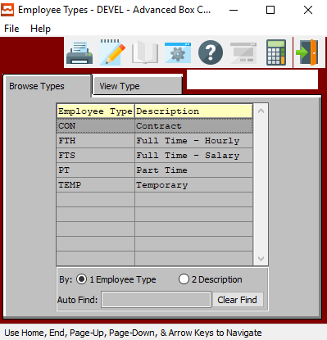

In order to view detailed information for a specific employee type, the desired type must be selected within the list of all available employee types. The user may search for a specific type, or narrow down the browse list, by using the search field located at the bottom of the page.

In order to select a specific employee type within the list to view detailed information for, the user must ensure that it is highlighted within the list. In order to highlight the desired type, the user may click on their desired employee type.

#### View Type

Once the user has highlighted their desired employee type to view detailed information for, they may click on the ***“View Type”*** tab at the top of the screen. This tab allows the user to view detailed information, as well as update and add employee types.

### View Type

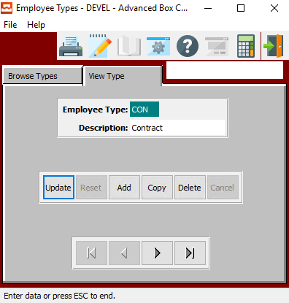

#### UPDATE

To change the currently selected employee type, simply click the ***“Update***” button at the bottom of the screen.

#### ADD

Click the ***“Add”*** button at the bottom of the screen to add a new employee type.

#### COPY

Click the ***“Copy”*** button to copy information from the currently selected employee type.

#### DELETE

To delete the currently selected employee type, simply press the ***"D"*** key. Alternatively, click the ***“Delete”*** button at the bottom of the screen.

#### NEXT

Press ***"N"*** (Next) to find next employee type to view or modify. Alternatively, press the ***“Right Arrow”*** on the screen.

#### PREVIOUS

Press ***"P"*** (Previous) to find previous employee type to view or modify. Alternatively, press the ***“Left Arrow”*** on the screen.

### Add/Update Type

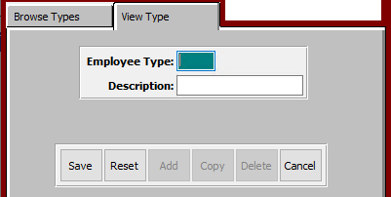

#### SAVE

Click the ***“Save”*** button to save all changes to the current employee type.

#### RESET

Click the ***“Reset”*** button to reset all fields to their original state.

#### CANCEL

Click the ***“Cancel”*** button to cancel all changes to the employee type without saving.

### Add/Update Type Field Definitions

#### Employee Type

Enter a short code for this employee type.

#### Description

The user may enter a short description for this employee type in this field.

## Repost Touch Data to ASI Database [TF@]

### Selection Parameters

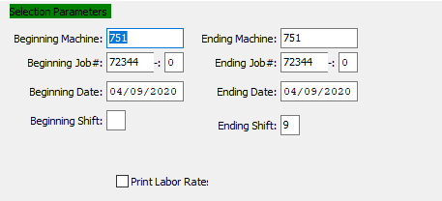

#### Beginning Machine / Ending Machine

Enter the beginning and ending Machine Code to repost touch data for.

#### Beginning Job # / Ending Job #

Enter the beginning and ending Job Number to repost touch data for.

#### Beginning Job #: 00 / Ending Job #: 00

Enter the beginning and ending Subsequent Job Number to repost touch data for.

#### Beginning Date / Ending Date

Enter the beginning and ending Date to repost touch data for.

#### Beginning Shift / Ending Shift

Enter the beginning and ending Shift Number to repost touch data for.

#### XXX – Toggle Box

To print the labor rate on the report, make sure that the Print Labor Rate toggle box is checked.

### Output Destination

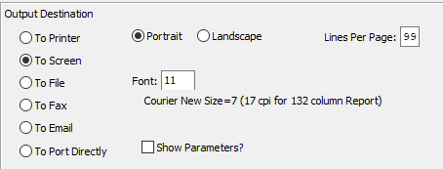

#### Destination Choice

To choose the destination where the document should be printed, please make sure that desired output destination choice bubble is toggled.

#### Layout Choice

To choose the preferred layout of Landscape vs. Portrait, please make sure the desired option choice bubbled is toggled.

#### Lines Per Page

Lines per page on the report when printing.

#### Font

Enter the font number to use with this report (Font 11 is default).

#### Show Parameters? – Toggle Box

To show parameters, make sure that the toggle box is ‘ticked’ with a checkmark.

#### Export to Excel? – Toggle Box

To export the printed file to an excel document, make sure that the Export to Excel toggle box is checked.

#### Auto Run Excel? – Toggle Box

To automatically open the new excel document, make sure that the Auto Run Excel toggle box is checked.

#### If Yes, File Name

If exporting the file to Excel, enter the desired file name.

## Purge Employee Transaction [TF#]

### Selection Parameters

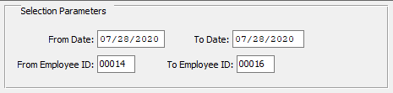

#### From Date / To Date

Enter the beginning and ending Date to purge transactions for.

#### From Employee ID / To Employee ID

Enter the beginning and ending Employee ID Number to purge transactions for.

## Purge Touch Data [TF$]

### Selection Parameters

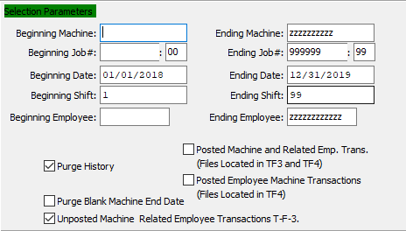

#### Beginning Machine / Ending Machine

Enter the beginning and ending Machine Code to purge touch data for.

#### Beginning Job # / Ending Job #

Enter the beginning and ending Job Number to purge touch data for.

#### Beginning Job #: 00 / Ending Job #: 00

Enter the beginning and ending Subsequent Job Number to purge touch data for.

#### Beginning Date / Ending Date

Enter the beginning and ending Date to purge touch data for.

#### Beginning Shift / Ending Shift

Enter the beginning and ending Shift Number to purge touch data for.

#### Beginning Employee / Ending Employee

Enter the beginning and ending Employee ID Number to purge touch data for.

#### Posted Machine and Related Employee Transaction – Toggle Box

To purge posted machine and related employee transactions within the selected parameters, make sure that this toggle box is checked.

#### Posted Employee Machine Transactions – Toggle Box

To purge posted employee machine transactions within the selected parameters, make sure that this toggle box is checked.

#### Purge History – Toggle Box

To purge history within the selected parameters, make sure that the Purge History toggle box is checked.

#### Purge Blank Machine End Date – Toggle Box

To purge blank machine data within the selected parameters, make sure that the purge blank machine end date toggle box is checked.

#### Unposted Machine Related Employee Transactions – Toggle Box

To purge unposted machine-related employee transactions within the selected parameters, make sure that this toggle box is checked.

### Excel Export



#### Export to Excel? – Toggle Box

To export the printed file to an excel document, make sure that the Export to Excel toggle box is checked.

#### Auto Run Excel? – Toggle Box

To automatically open the new excel document, make sure that the Auto Run Excel toggle box is checked.

#### If Yes, File Name

If exporting the file to Excel, enter the desired file name.

## Purge Zero Time Transaction [TF%]

### Selection Parameters

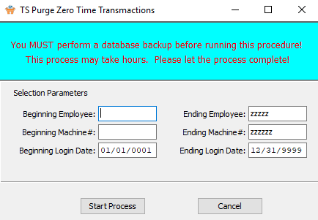

Please Note: The user must perform a database backup before running this procedure to secure against lost data.

#### Beginning Employee / Ending Employee

Enter the beginning and ending Employee ID Number to purge zero-time transactions for.

#### Beginning Machine # / Ending Machine #

Enter the beginning and ending Machine Number to purge zero-time transactions for.

#### Beginning Login Date / Ending Login Date

Enter the beginning and ending Login Date to purge zero-time transactions for.

# **Copy or Replace Machine (STRIP)**

This job is estimated with hand stripping machine called ***STRIP***. In touch screen, each operator must log in to a machine. If each employee logs into the ***STRIP*** machine then any job data collection will post their time to that job.

For example, we have four men that log into the ***STRIP*** Machine at 7AM and Logs out at 3PM. Each man works on four separate jobs. This will post hours for all four men to all four jobs which results in bad job costs.

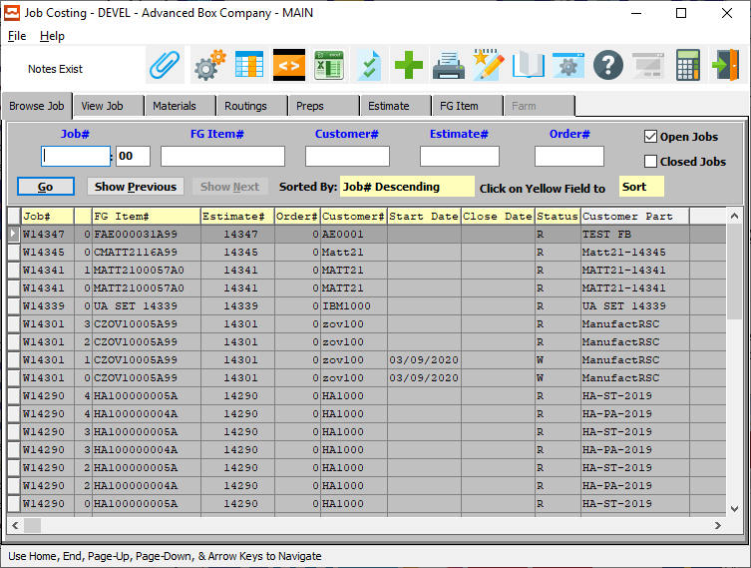

## Touch Screen: Machine Code

The solution is to create a unique machine code for each person.

For example, HS1, HS2, HS3 and HS4 representing Hand Stripping for Employee one to four. Then each person logs into his own machine code and logs in an out of each machine and enters his own job data collection. When posting job data collection, the employee should ***Copy*** their machine.

If two hand strippers are on the ***Same Job***, the ***Replace*** option would remove the first persons machine from the job file.

First Step is to Create Unique Machine Operations in the machine File.

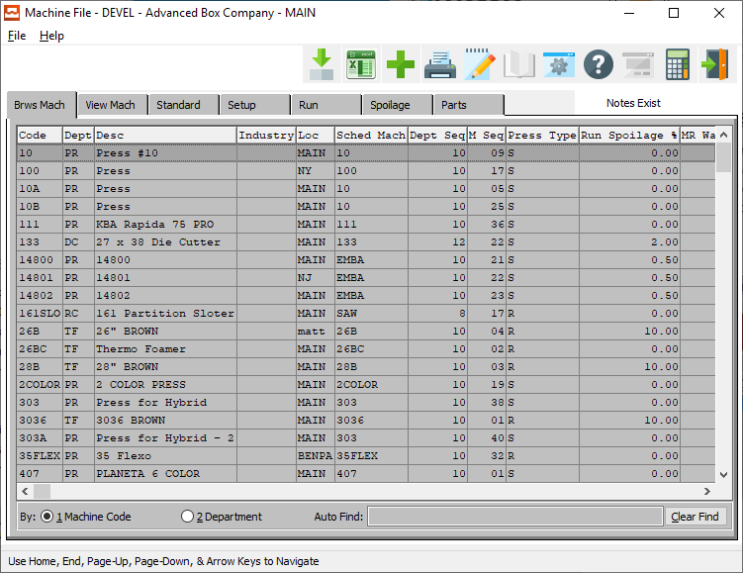

The next Step is for each employee to login to their specific machine code.

Please Note: The user can create a machine code as the employee ID to simplify data entry. They select their machine code / Employee ID.

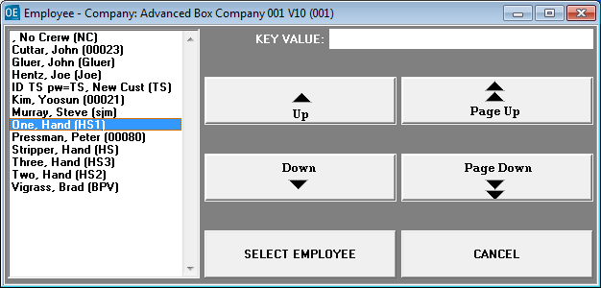

All the machines and operations that employees have logged into will appear on the machine status button so management knows that the machine is ready to run jobs.

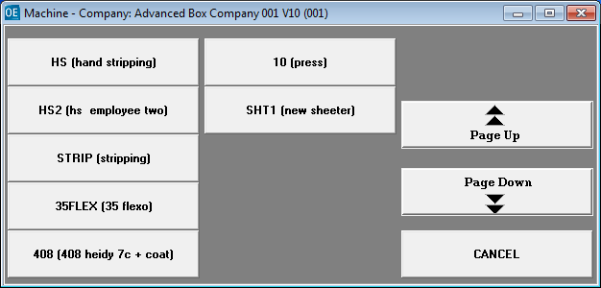

## Touch Screen: Job Data Collection

Next enter ***Job Data Collection*** and select the ***Hand Stripping***.

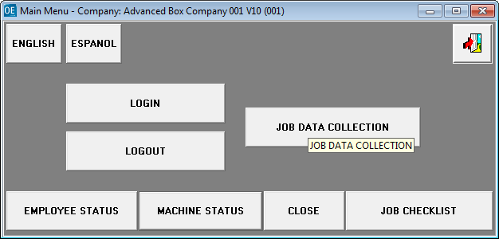

## Touch Screen: Enter Job

The job was estimated with the machine code ***STRIP***. The employee must log onto the machine operation created for him specifically then add labor hours for each job that he works on each day. All the operation codes Strip, HS, HS1, HS2, HS3 and HS4 are in the same department code HS. The program prompts to ***Copy*** or ***Replace*** this machine operation code to the Job file.

When multiple machine codes for the same department, enter time for the same job, this prompt will appear. Press ***Copy*** when more than 1 operators are running job. If only 1 man is on the job then they will select ***Replace*** to then show only one HS department machine code in the job file, job card and job reports.

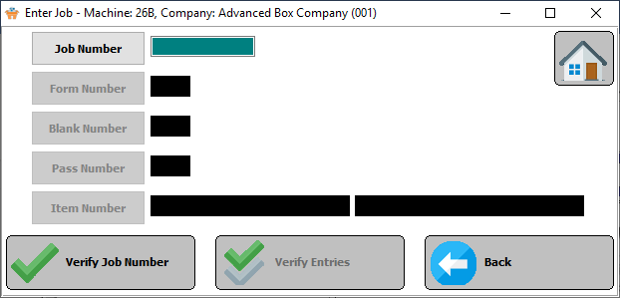

## Touch Screen: Operator Code

Each operator enters his own machine setup and run times to his own machine operation code by selecting the ***Copy*** button. By having their own operator code, they can move from job to job or work together on the same job. The job cost system will only post hours and cost by the machine operation code.

